2/10/2020

Recommendation

I have retained Christopher McGrath’s academic services and have been working with him several weeks for a College Mathematics Survey course that has various math topics from Algebra, Statistics, Number Theories, and other foundational topics. I am an adult student returning to college for advancement in my career and education at Daytona State College, FL, www.daytonastate.edu. So far, he has helped me catch up with assignments and build my level of confidence and smooth learning atmosphere while I work on my assignments. Chris is strict with schedule appointments, but he is always reliable and professional.

I positively summarize his qualities with the following outlines:

- Competent
- Punctual and reliable
- Friendly and professional.

It has been a pleasurable experience to find Chris to work with for this course. He will continue to be helping me out until the end of the course. Please feel free to call me or email me at the contact info below if you have any further question to verify my recommendations.

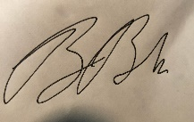
Brian (Confidential Last Name)
salesbiz99@gmail.com
407 721 4466

