12/17/20

To whom this may concern,

I had been a regular customer to Arts of Ancient Wisdom (AAWISDOM.com), and I recommend it to anyone. Christopher McGrath helped me with my intensive time-sensitive materials in my Statistic course throughout the difficult times.

I knew he was very trustworthy, intelligent, and competent in handling overwhelming time-sensitive complex academic topics. I obtained 80% final grade from a failing grade. Not only this was a full statistic course with all topics in statistics covered rigorously, but also there was three major assignments applied to real world data for many techniques covered in course. In addition, there were two major tests. The amount of materials covered each week were very unfair with demands and time-sensitive. Being an employed military veteran, I would not be able to pass this course without Chris’s help.

I am truly grateful with all the help, efforts, and valuable services I received. Please feel free to email me if you have any further question to verify my recommendations.
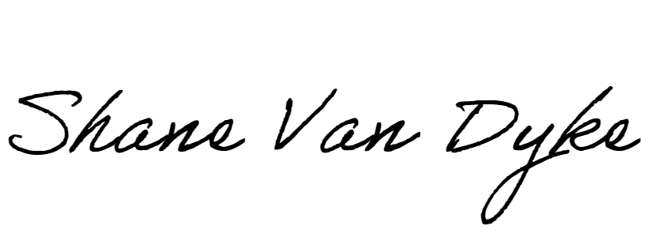

Shane Van Dyke
shane.vandyke@outlook.com
315 921 6821
Student

