The included angle of the two sides of equal length s in an isosceles triangle is θ. Show that the area of the triangle is

- $A=\frac{s^{2}}{2}\sin{θ}$.
- Answer in the textbook.
- Answer in the textbook.

First, the “included angle of this problem” is the angle between the two equal sides. In order words we have to prove that area of the isosceles triangle is $A=\frac{s^{2}}{2}\sin{θ}$, aside from our usual A= ½ Base x Height formula.

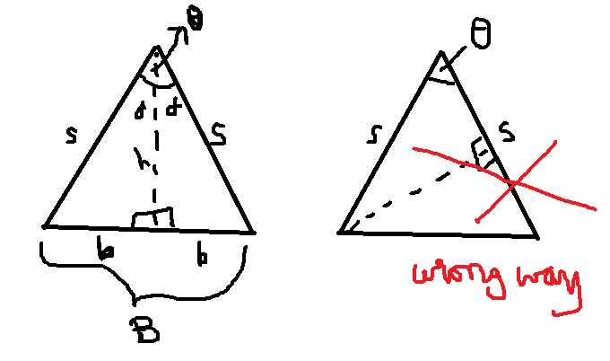
Figure 1.

The problem is from Page 170, #15 Calculus Early Transcendental Functions by (Larson, Hostetler, & Edwards, 1995), ISBN 0-669-39349-5.

The key catch is to use the idea of Double Angle Formula$\sin{2u}=2\sin{u}\cos{u}$.

A = $\frac{1}{2} B.h$ --- (eq1)
$A=\frac{s^{2}}{2}\sin{θ}$ or A = $\frac{1}{2}s^{2}\sin{θ}$ ---- (eq2)

From comparing eq1 and eq2, I make a strategy to prove that

B . h = $s^{2}\sin{θ}$.

b = s $\sin{∝}$
h = s $\cos{∝}$

Note that B = 2 x b, therefore, B = 2 s $\sin{∝}$.

Now we substitute into eq1

A = $\frac{1}{2} B.h$
A= $\frac{1}{2}$ 2 s $\sin{∝}$ s $\cos{∝}$ ------ eq3.

Rearrange the equation 3 above to A= $\frac{1}{2}$ $s^{2}$ 2 $\sin{∝}$ $\cos{∝}$.

2 $\sin{∝}$ $\cos{∝}$ part from the above equation is where we will apply the Double Angle Formula
$2 \sin{∝} \cos{∝} =\sin{(2∝}$) .

Applying the Double Angle Formula for Sine, 2 $\sin{∝}$ $\cos{∝}$ will become $\sin{(2∝}$):
A= $\frac{1}{2}$ $s^{2}$ $\sin{(2∝}$) ----- eq4.

Looking at the Figure 1, note that θ = 2 x$∝$, therefore substitute $\sin{(2∝}$) = $\sin{θ}$ to eq4:

A= $\frac{1}{2}$ $s^{2}$ $\sin{θ}$, which is the same is eq2, our objective to prove. Part (a) is resolved. Other parts have answers in the back of the book, except that part (a). If you need a math tutor, visit www.aaw.link.

The above problem is tricky because there are several possible strategies to pick, such as Law of Sine Equation, Law of Cosine Equation, or Pythagorean Equation, but all of them failed. Lesson to learn is that in the case of isosceles triangles, if we know the equal sides’ measurements and the measurement of angle between them, we don’t need to know the base and height measurements to compute the Area.

Professional Statement from AAW Tutor (www.aaw.link) about Dirty Tricksters

A problem like this one is for honor students designed to challenge to think and spend time. Even experienced mathematician and a tutor like Christopher McGrath could not see the clear path without trying failed equations above. I knew vaguely the path would be to apply one of Trigonometric Identities or could be to use one of the three equations above. The trickster does not give us a clue like use Double Angle Formula for Sine. This is a dirty sneaky trick--concealment. There are many problems like these the “tricksters” stick into math textbooks to waste our times. Textbook publishers should reorganize their contents and put elite sections in the books purely consist of problems like this one that are to challenge elite students. I appreciate these challenging problems, but I don’t like to see them among other straightforward problems and not being able to identify the special ones. Problems like these slow down the learning process for students who are merely learning the essential topics. This kind of practice is to hurt education, students, teachers and tutors, and life itself. People are discouraged and intimidated to learn mathematics in life, and knowledge isn’t progressing faster than the past. This is just an example of a dirty trick I see among many textbooks for math, physics, chemistry, etc. The dirty tricksters behind these practices have cheap intent to waste other people’s times. Their intentions aren’t good and these tricksters are not intelligent geniuses.

AAW Tutor’s Revelation of the Corrupt Education System in the USA

Many high school teachers are incompetent twisted liars because of the corruption called Teacher Certificate requirement in public education system. The training program for the Teacher Certificate is amazingly stupid and deceptive that it became a haven to attract decadent flawed-character liars. For AAW standards, only a few subjects are truthful education, such as mathematics, physics, or chemistry. Other subjects are only embellishments to drive students towards real educations. Subjects like mathematics are for real honest lucent characters that require honest intention behind a character to learn. The people who cannot withstand certainty, decisiveness, truthfulness, proofs, intellectual-rigor, and natural scientific laws (like mathematics) embrace ambiguous fanciful corrupt practices, which are deviations from the truths, embodied into false studies no one should waste their lives going about. Many college students who go for Teacher Certificate Program are dim students who hate mathematics because they are incapable of passing beyond Calculus I or even below-level math courses. Teacher Certificate Program does not train specialized teachers for subjects like mathematics and other highly complex subjects. Thus, those dim subtle flawed-character people passed their college education in Teacher Certificate Program, which consists of much nonsensical subjects to fill the college credits requirements to become “Teachers” for high school students. They steal the good traditional word “Teacher” with this corrupt process created by stupid politicians, but these “Teachers” do not and cannot really teach. They are like a police to enforce the students do the required works in course outline (curriculum) pretending they are capable of understanding it themselves, which was created by someone else. This hypocritical system attracts dim shallow insincere students to become teachers for young students in the USA. Real passionate intellectually vigorous students who majored in Applied Mathematics, Physics, Chemistry, etc. cannot teach or become “Teachers” in high school because they do not hold Teacher Certificate. They have to waste their times, and money going back to college and spend times among lying lame people in that Teacher Certificate program in order to teach what they are really good at.

Hiring practice in schools are corrupt too. The process selects not the best-capable intellectual, but most capable double-talking liar who would please HR department losers, lying-lame principal, math department chairperson (only valid person for interview), athletic-coach dean (with loser academic background), and all kinds of various phony characters that made up a so-called ridiculous committee. As the results, the students will suffer and grow in resentment for environment made of lying lowlife dimwit phonies. The mission of the Arts of Ancient Wisdom (AAW.link) is to make geniuses and make people break their limits constantly and ascend to limitless potentials, unlike the System that obstructs. Get real educations from a real teacher/math tutor at www.aaw.link.

