Door Entry Documentation for Sage Area (where North and South Mole Cars are)
When the Automation System is in Run Mode:
- Press REQUEST ENTRY button. Sage robots and mole cars will finish up their tasks and GREEN LIGHT (about the size of a Quarter) on the door should turn green when it is ready in less than 5 minutes (see image 1).
- TURN the KEY and TURN the BOLT. NOTE: “Door 1” (by the CC1 Panel) is not cooperative with opening gently. The bottom area by your feet must be kick lightly to make it open while pulling it with the bolt held turned.
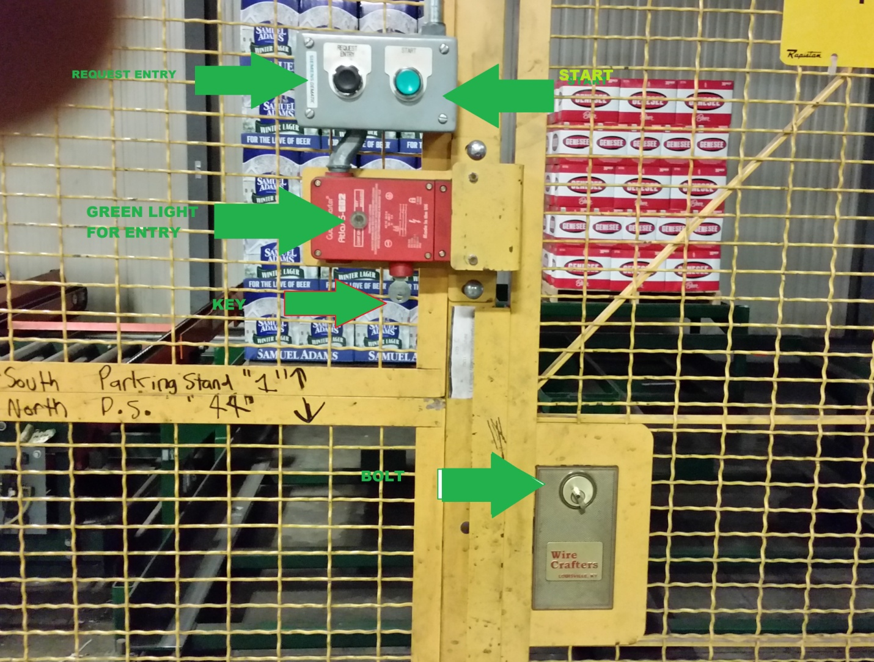
Image 1: Door Entry for CC1 Area Door
- The System will be in halt or fault mode while the door is open. CLOSE THE DOOR when your tasks inside the area are done and PRESS START button on the door. PRESS START button on the CC1 Panel (see image 2). Note: There will be a fault message on the panel view screen saying “Traversing Meter Fault” in red box. Not shown in picture.
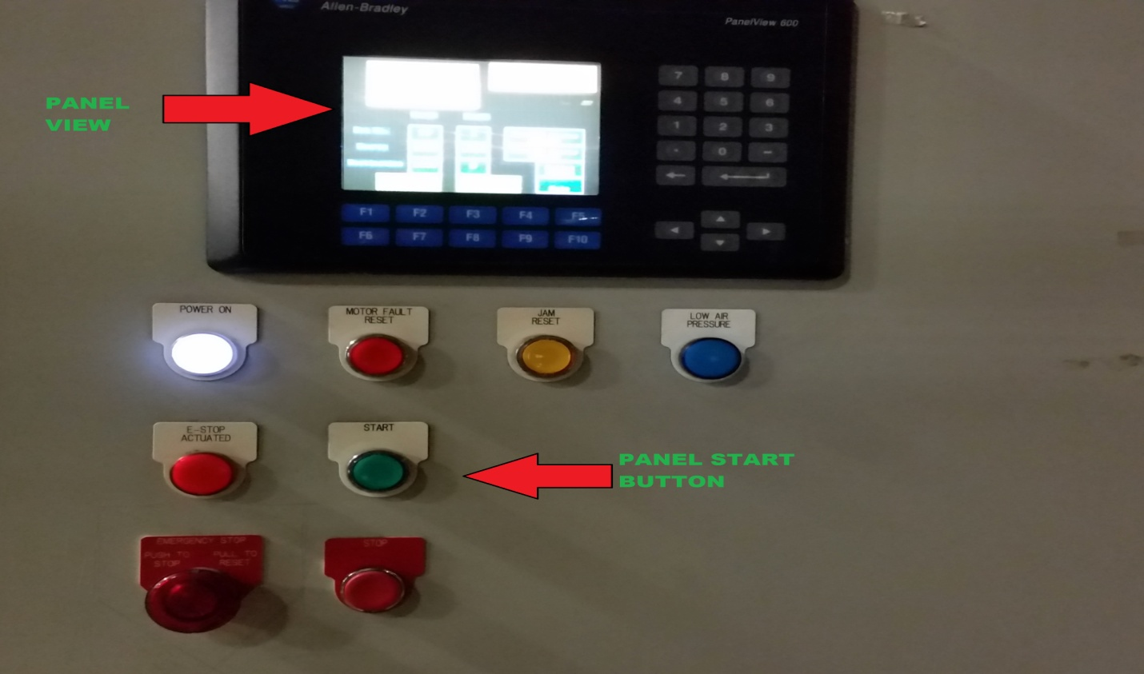
Image 2: CC1 Panel and Its LCD Panel View
- Press E-Stop RESET button and START ROBOT button on the Panel View Screen (see image 3) on each one of our Sage Panel. We have THREE Sage Panels. NOTE: To press START button on the Panel View Screen, you have to use mouse next to keyboard for Sage Panel. Sage Panel View Screens are not Touch Screen type.
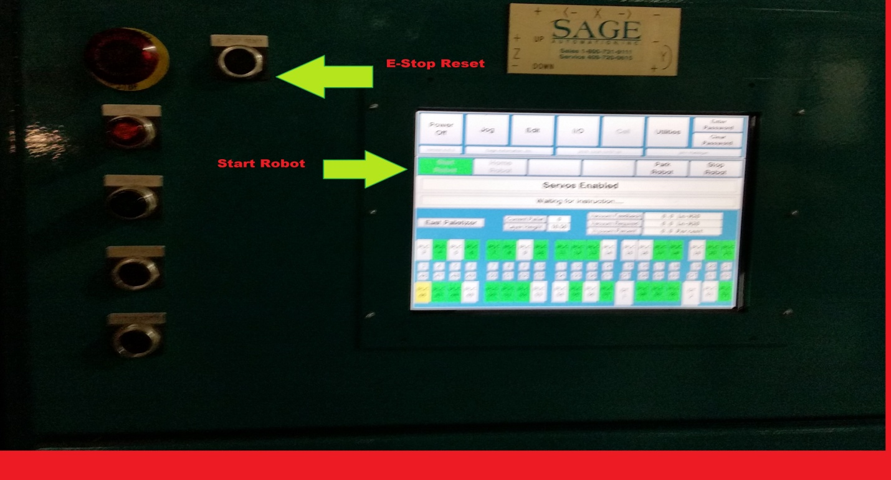
Image 3: Sage Robot Panel

Additional Comments:
- When the System is NOT in RUN MODE, executing STEP 3 is sufficient to RESET the system. No Sage’s E-STEP RESET and START ROBOT button needed.
- When the OTHER DOOR (nearby other two Sage Panels by far West Side of the Sage Area) is used for entry, apply the same reset procedures on THAT DOOR’s buttons. Pressing START button on the CC1 Panel is not needed and no SAGE’s E-STOP RESET button needed when the system is not in run mode.

