Gold Quest Software User Guide
By
Christopher McGrath
Mcgrath_ch@hotmail.com
May 20, 2014

Table of Contents
Introduction 4
Super Admin 5
Section 2.1: Super Admin Credentials 5
Section 2.2: Super Admin Capabilities 5
Subsection 2.2.A: Dashboard Tab 5
Subsection 2.2.B: Customers Tab 5
Subsection 2.2.C: Reports Tab 7
Subsection 2.2.D: Admin Tab 8
Subsection 2.2.E: Super Admin Control All Other Users 8
Subsection 2.2.E.1: Creating a New Employee 9
Subsection 2.2.E.2: Editing Employees 11
Subsection 2.2.E.3: Creating or Editing Corporations 13
Subsection 2.2.E.4: Creating or Editing Stores 15
Subsection 2.2.E.5: Creating or Editing Regions 18
Subsection 2.2.E.6: Creating or Editing Referral Sources 19
Section 2.3: Transactions Icons at Reports for Super Admin 20
Subsection 2.3.A: Transactions by Store 20
Subsection 2.3.B: Transactions by Employee 21
Subsection 2.3.C: Incomplete Transactions by Employee 22
Section 2.4: Shipments by Store Icon at Reports for Super Admin 22
Section 2.5: Inventory Icons at Reports for Super Admin 24
Subsection 2.5.A: Inventory by Store 24
Subsection 2.5.B: Inventory by Status 24
Section 2.6: Transactions by Customer Icon at Reports for Super Admin 24
Section 2.7: Referrals by Store Icon at Reports for Super Admin 25

Section 2.8: Points by Employee Icon at Reports for Super Admin 26
Section 2.9: Financial Icons at Reports for Super Admin 26
Subsection 2.9.A: Receive Payments 26
Subsection 2.9.B: Profit/Loss 28
Section 2.91: Customers Tab for Super Admin 28
Section 2.92: Super Admin Limits 28
Subsection 2.92.A: Super Admin Cannot Make another Super Admin 29
Subsection 2.92.B: Super Admin Cannot Trade 29
Admin 29
Corporate 30
Section 4.1: Buy Tab for Corporate 30
Subsection 4.1.1: Step 1: Enter Item Information 30
Subsection 4.1.2: Step 2: Enter Customer Information 33
Subsection 4.1.3: Step 3: Confirm Transaction 35
Subsection 4.1.4: Step 4: Print Receipt 36
Section 4.2: Sell Tab for Corporate 36
Subsection 4.2.1: Step 1: Choose Items to Sell 36
Subsection 4.2.2: Step 2: How Are You Selling Items? 37
Subsection 4.2.3: Step 3: Confirm Shipment/ Sales 39
Subsection 4.2.4: Step 4: Print Statement 39
Manager-Region 40
Manager-Store 41
ASSOCIATE 42
AUDITOR 44
POLICE 45

Chapter 1

Introduction

GoldQuest Software is gold trading software owned by GoldQuest Refinement Services, LTD. It makes gold buying more efficient and easier compared to old-fashioned way. It has many modern technology applications integrated to alleviate the standard procedures in gold buying and selling process. Some examples of those applications are live price integration in the software, organized database for various purposes, speedy live criminal background check, and concise hierarchical management system for security purposes. GoldQuest Software is accessible at the URL https://secure.goldquestsoftware.com.

Chapter 2

Super Admin

The best way to approach in describing the capabilities, and structure of the GoldQuest software is to begin by describing the Super Admin user.
Super Admin user has the highest authority. This user can add or delete all other users. At the time this manual is being written, there is only one Super Admin user and one password for the entire control structure of the GoldQuest software. Super Admin user is intended for the GoldQuest company employee to monitor and manage the entire software. This user is created directly by software developer from the backend codes.

Section 2.1: Super Admin Credentials
Super Admin User Name: superadmin.
Super Admin Password: goldquest.
The above credentials are directly created by the software developer team. Super Admin credentials, such as user name, password, and status (active or inactive), cannot not be edited from the end user side like from the internet browsers. For the various reasons, the edibility of the Super Admin user’s credentials from the end user side is not tested.

Section 2.2: Super Admin Capabilities
The following is the immediate control panel of the Super Admin at the log in. Super Admin has four tabs: Dashboard Tab, Customers Tab, Reports Tab, and Admin Tab.

Subsection 2.2.A: Dashboard Tab
The Dashboard Tab shows Live Spot Prices of Gold, Silver, and Platinum for one troy ounce each. The Super Admin cannot ship anything; therefore, the Shipping Alert message is not applicable for this user.

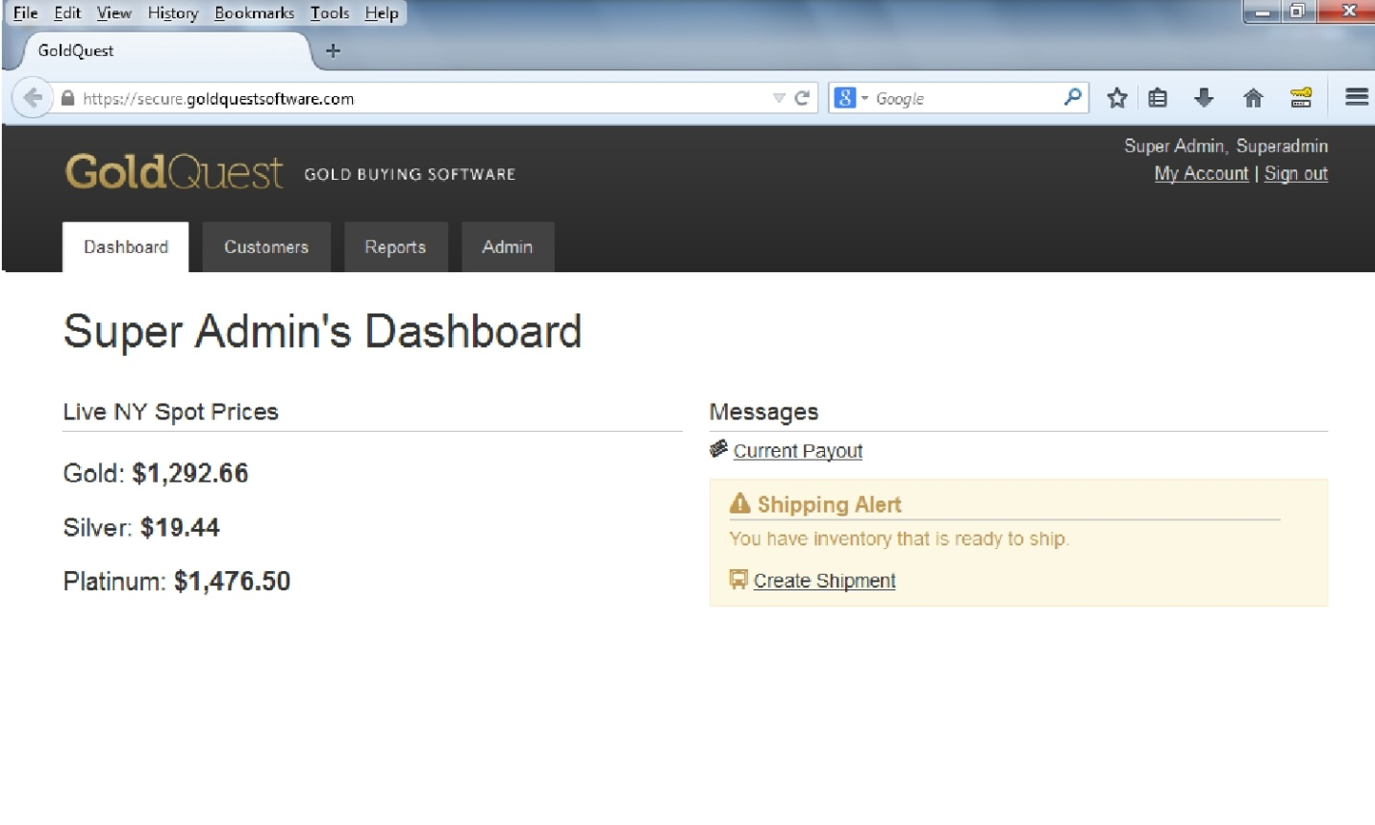

Image 2.2.A: Super Admin Tabs at Dashboard

Subsection 2.2.B: Customers Tab
The Customers tab shows the list of all users in the software environment for the Super Admin. Search box with regular filter, search by last name, or advanced Search is available to locate other users more efficiently. NOTE: Clicking on the column header s will sort rows below. This sorting function is available for all lists in the GoldQuest software environment.
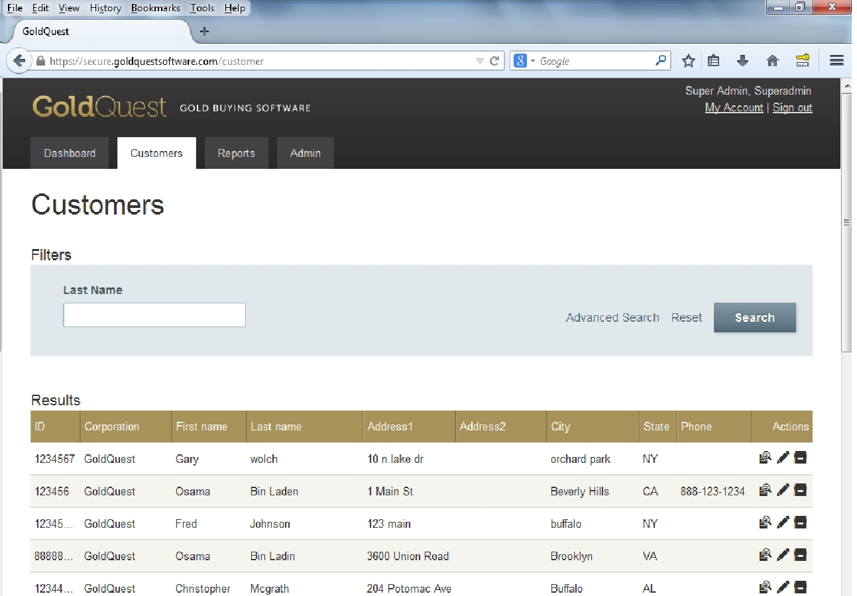

Image 2.2.B: Customers Tab for Super Admin

Subsection 2.2.C: Reports Tab

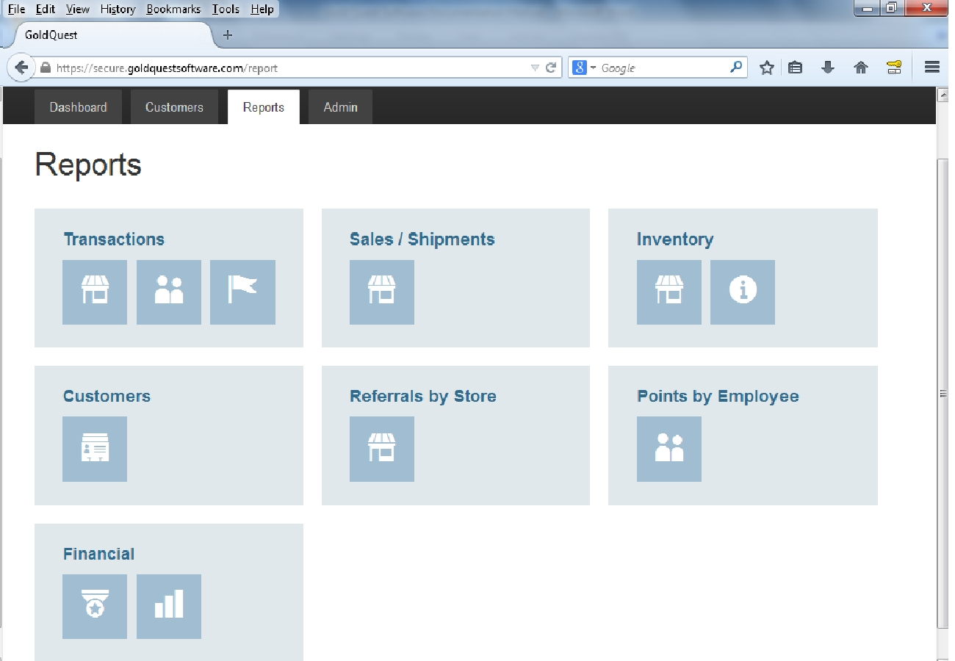

Image 2.2.C: Reports Tab for Super Admin
The Reports tab for the Super Admin contains six more categories and additional functionalities displayed with icons with in those categories as in the image 2.2.C.

Subsection 2.2.D: Admin Tab

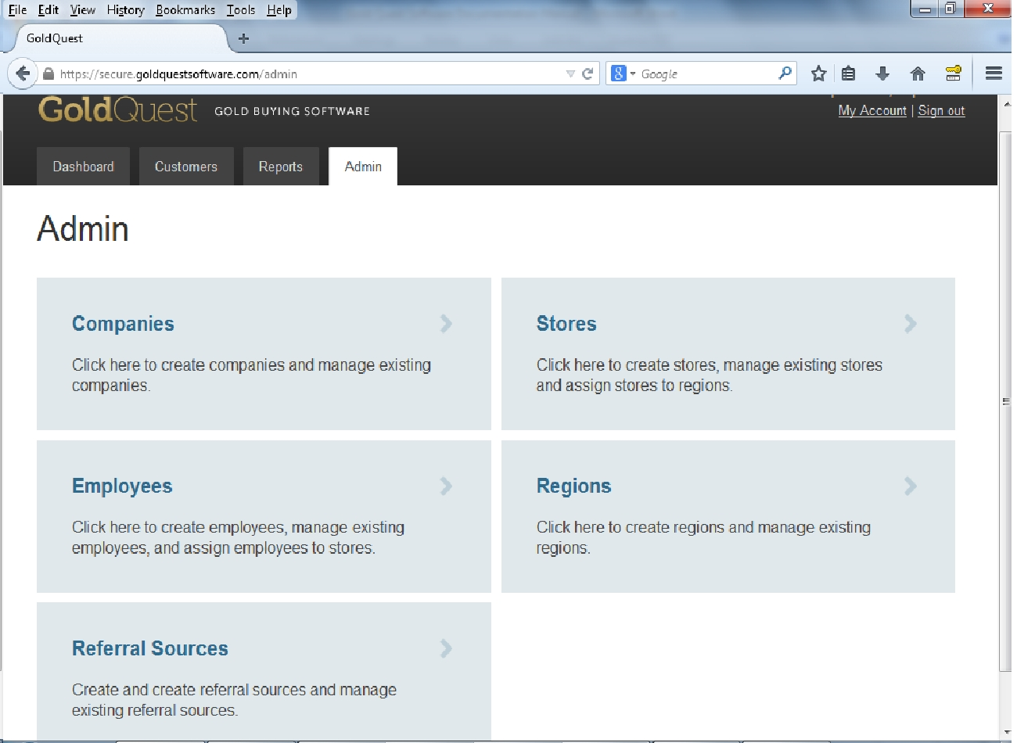

Image 2.2.D: Admin Tab for Super Admin
The Admin tab for the Super Admin contains six more categories as in the image 2.2.D.

Subsection 2.2.E: Super Admin Control All Other Users
Super Admin can:
- Create all other users, such as Admin, Corporate, Auditor, Manager-Region, Manager-Store, Associate, and Police (Please see section 2.2.E.1 for further information).
- Create, view, or edit all other users’ credentials and user information, and other accounts, such as corporation and store information and others. Some example of Super Admin’s abilities are creating or editing corporation assignment, user name, password, email address, role, status (deactivate or reactivate), names, address, store assignment, and write some notes about the particular user. (Please see section 2.2.E.2 for further information.)
- Create, view, and edit all corporations and their basic information. (Please see section 2.2.E.3 for further information.)
- Create, view, and edit all stores associated to all corporations and their basic information. (Please see section 2.2.E.4 for further information.)
- View or edit assigned corporations to regions to classify them for better efficiency in managing them. (Please see section 2.2.E.5 for further information.)
- View of edit the referral sources of corporations for better marketing purpose. (Please see section 2.2.E.6 for further information.)

Subsection 2.2.E.1: Creating a New Employee
Super Admin can view, create, or edit all other users for the entire software environment in the Employee Category Box. Please see the image 2.2.E.1 as an example. For a Super Admin to create a new employee:
- Click Admin Tab
- Click Employees Category Box
- Click blue color New Employee Button at near right top corner of the screen.
A screen similar to image 2.2.E.1 will appear. First entry Corporation will appear as a drop-down list if at least one corporation is created. Selected corporation in this drop-down list will be assigned to the employee who is being created. For the Role drop-down list, only choosing Admin, and Corporate may grant the ability for that particular user to create additional users from their accounts.
If Is Active box is checked, newly created account will be active immediately and new user will be able to log in. Otherwise, the Super Admin may have to edit that account later and check that box to make that account active.
The Store in the Details section, a drop-down list will contain some stores if at least one store is created in the entire software environment. When selected, the particular store will be assigned to that user (employee).
The Points box will accept integers that could be used as reward or punishment system for the particular corporation for their employees. In the Points enabled accounts, the amount of new points the buying employee will earn will decrease (1 point for every $1) when payout price increase.

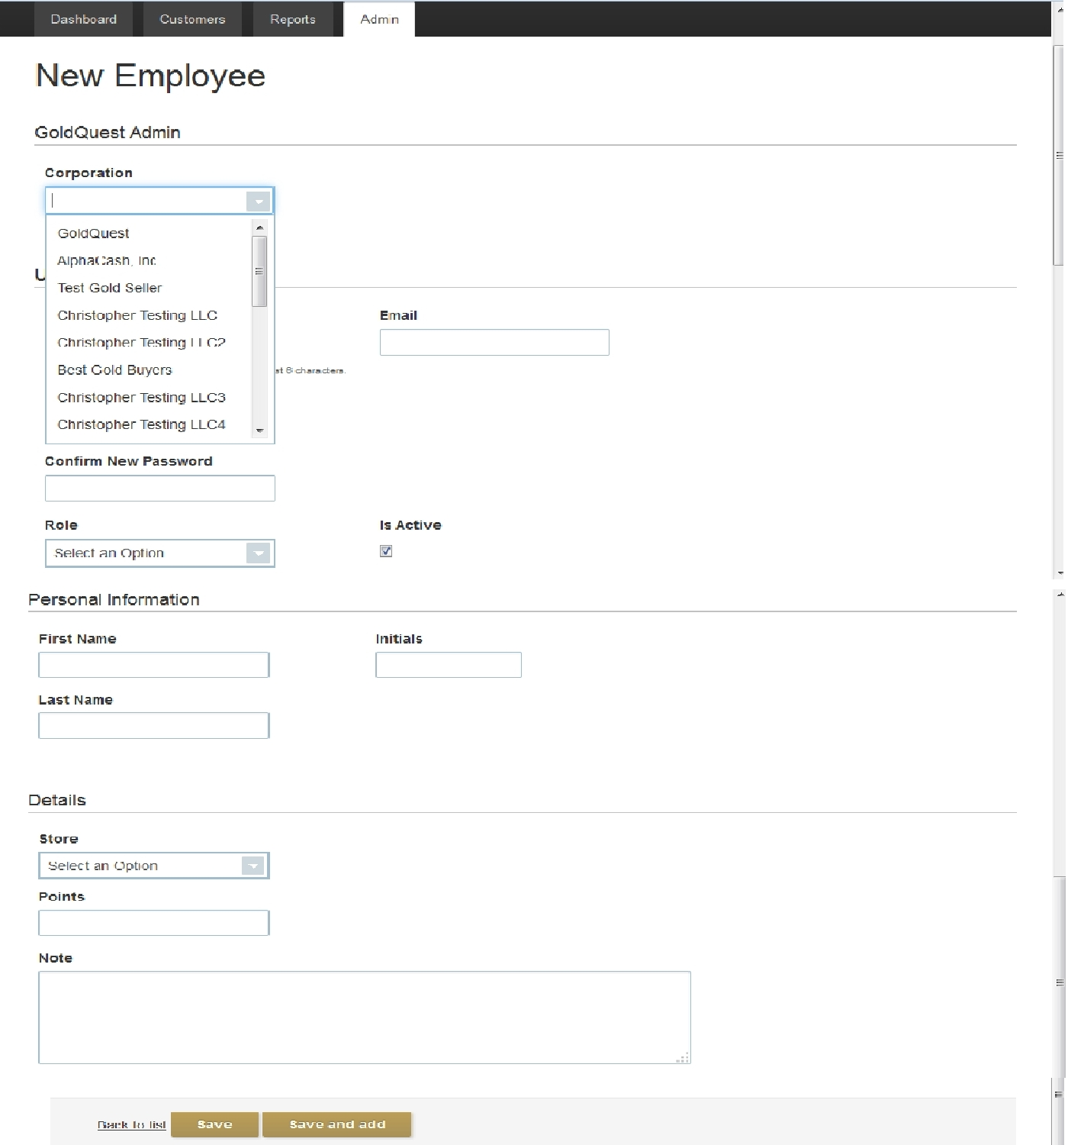

Image 2.2.E.1: Creating New Employee
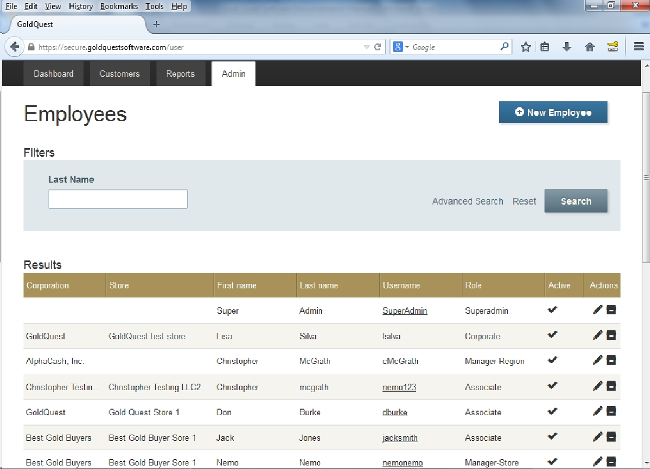

Image 2.2.E.1.b: Inside the Employees Category

Subsection 2.2.E.2: Editing Employees
To edit employees (also known as users for the Super Admin):
- Click Admin tab.
- Click Employees category.
- Click an icon appears as a pencil in image 2.2.E.1 to edit an employee.
A screen similar to Image 2.2.E.2: Editing an Employee will appear. Edit the fields and anything else to desired needs. Note: clicking on an icon that appears as box (archive) will delete that item from the GoldQuest software environment. This cannot be restored.

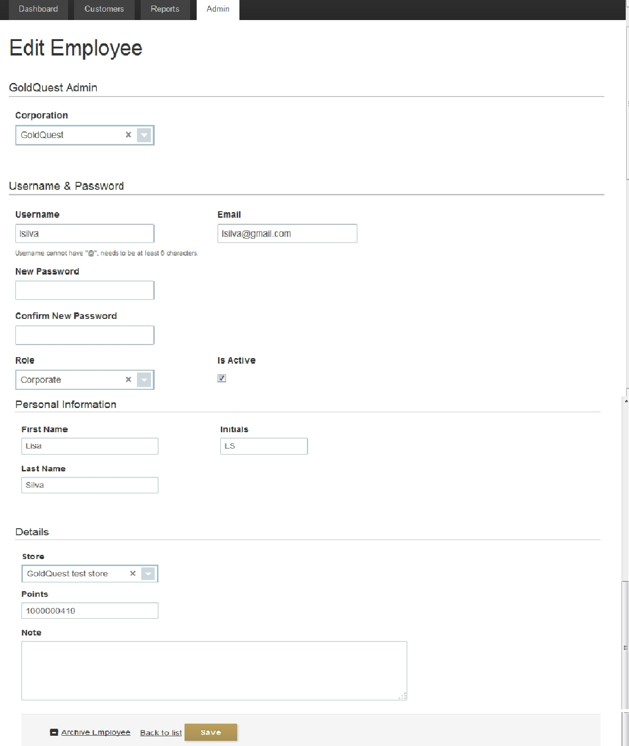

Image 2.2.E.2: Editing an Employee

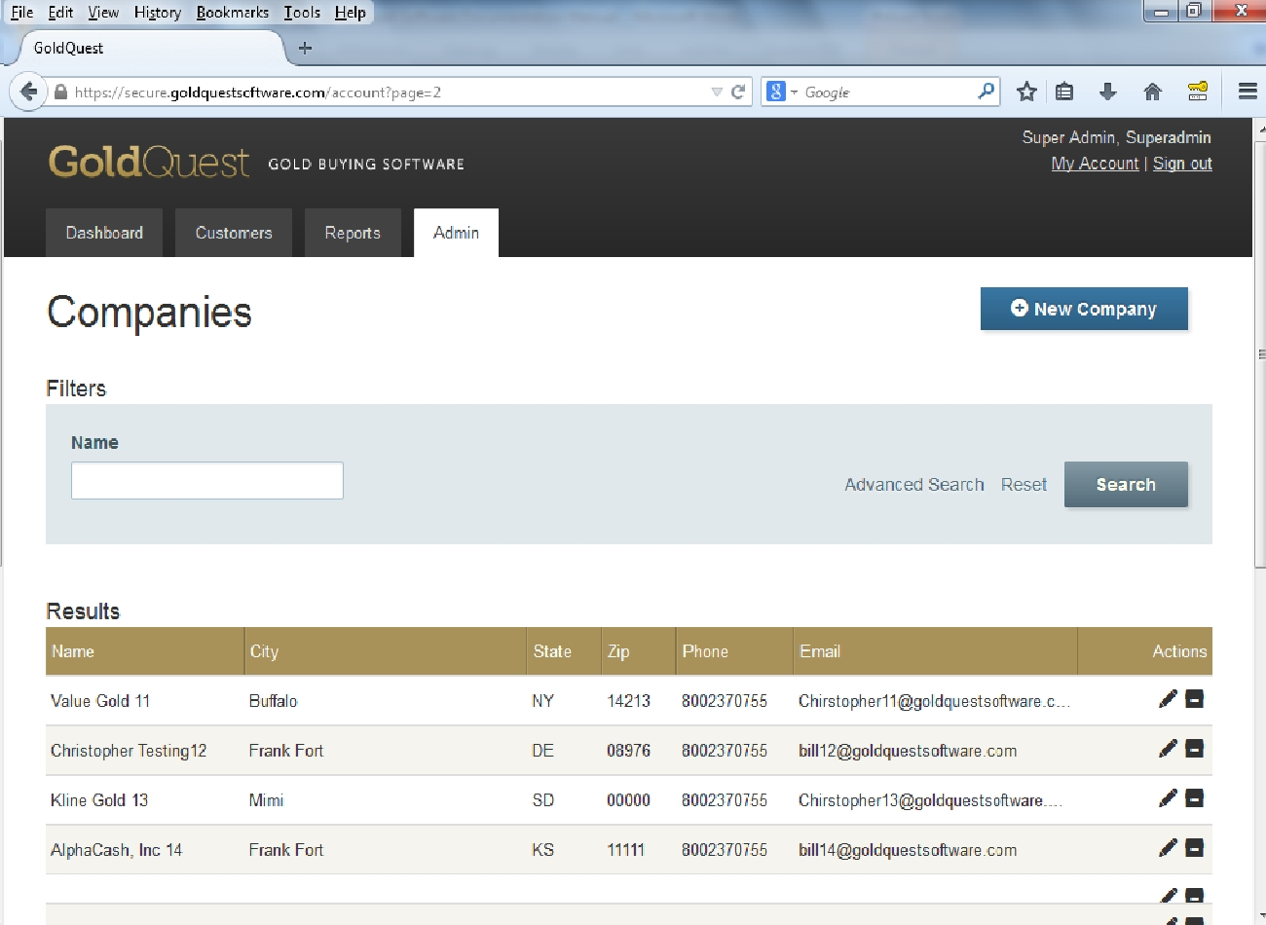

Image 2.2.E.3: Inside the Companies Category

Subsection 2.2.E.3: Creating or Editing Corporations
A screen to create a new company or to edit is the same screen as shown in Image 2.2.E.3.b: Editing a Company. Image 2.2.E.3: Inside the Companies Category above is an example of clicking into the Companies category from the Admin tab. To create a new corporation, click on the New Company button appears on right upper corner of the screen.
To edit companies:
- Click Admin tab.
- Click Companies category.
- Click an icon appears as a pencil in image 2.2.E.3 to edit a company.
A screen similar to Image 2.2.E.3.b: Editing a Company will appear.
Account Name – Enter the name for the company.
Primary Contact—Enter a person name to contact.
Employee Force Logout—Check this to logout any user inside this company at the end of completed buying or selling (shipping) transactions. Leaving this blank will enable the users to execute continuous transactions without the system logging them out.
Employee Point System –Leaving this unchecked will disable the display of points for that company.
Enable Metal Types–Only one metal is required to be checked. Additional ones can be checked. If left uncheck for any one, that company will not be able to buy or sell that metal.
Payout – This is the percent , calculated from the current NYS spot price of the metal, that GoldQuest Corporation will pay to that particular company if it decides to ship (resell) their inventory to GoldQuest.
Ship Value –This is the minimum value required for a company to ship (resell) their accumulated inventory.
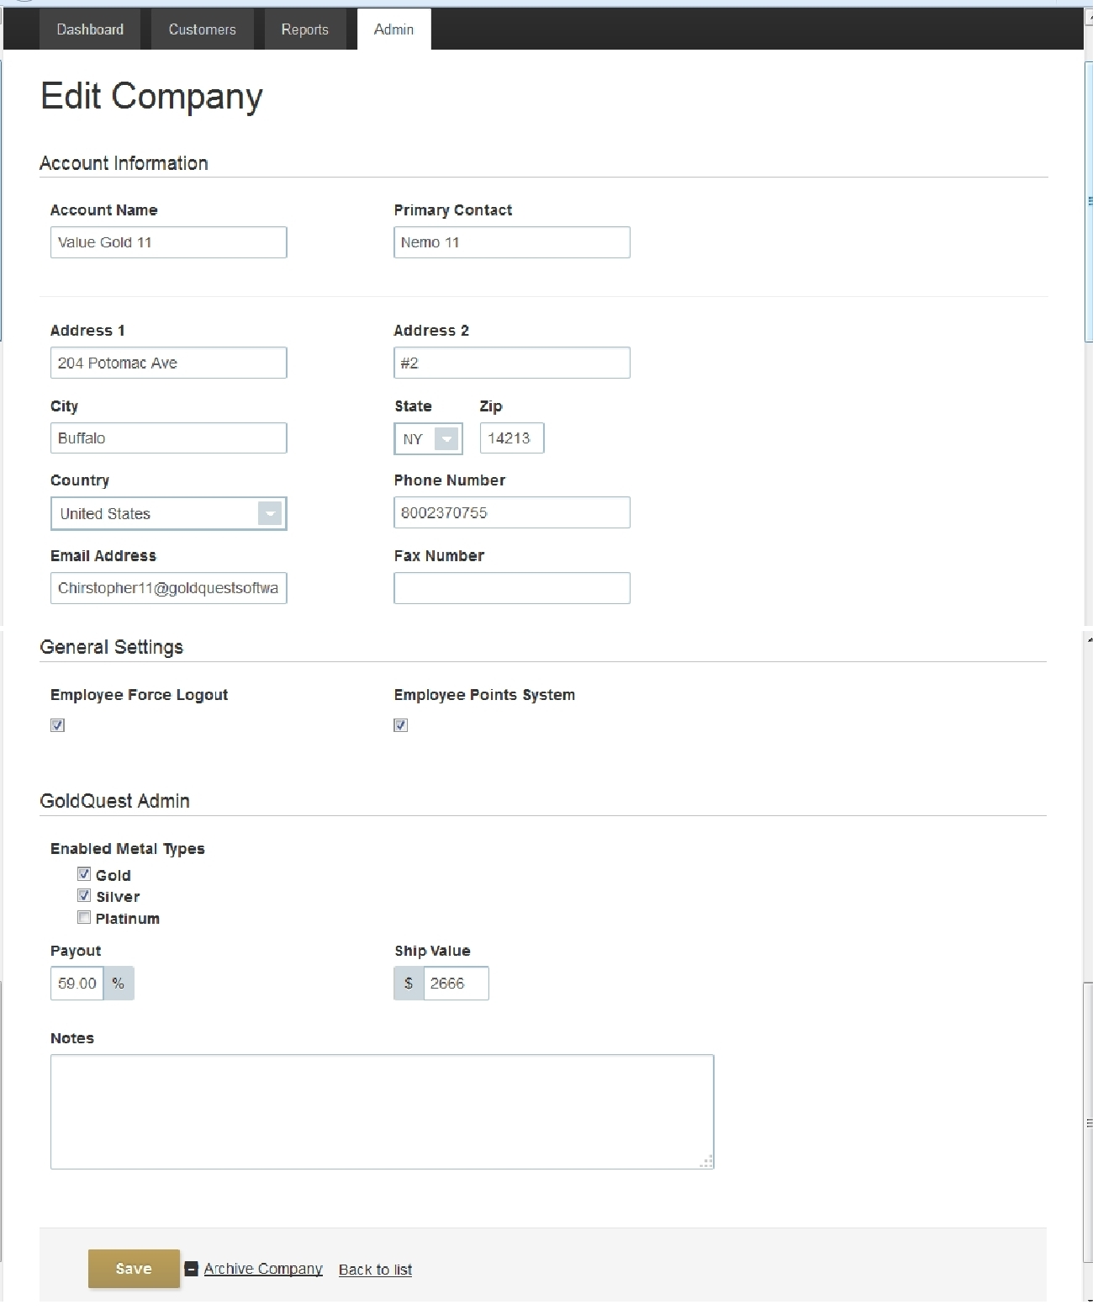

Image 2.2.E.3.b: Editing a Company

Subsection 2.2.E.4: Creating or Editing Stores
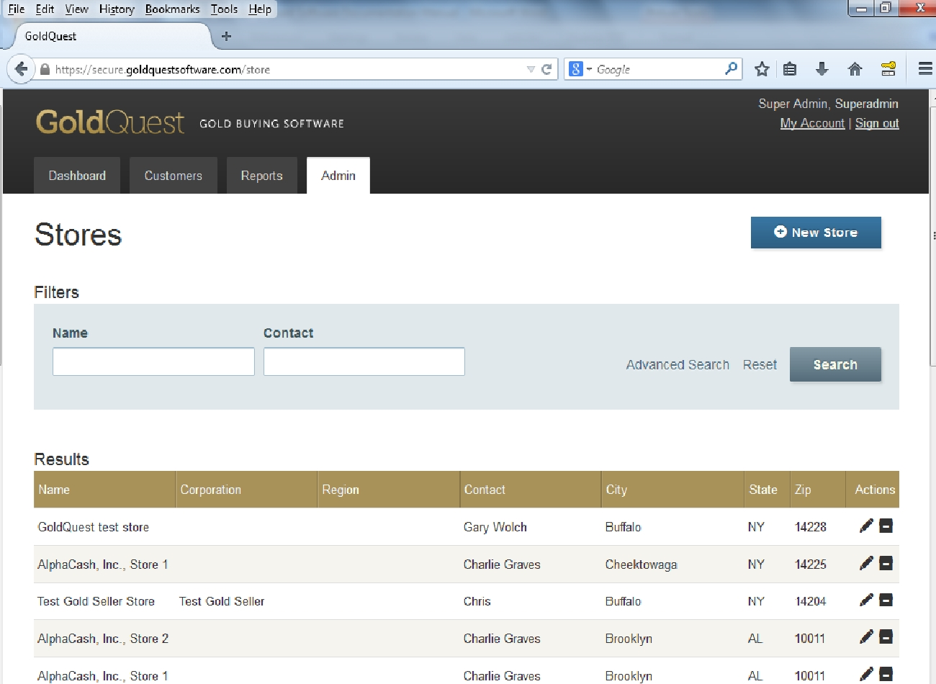

Image 2.2.E.4: Inside the Stores Category
A screen to create a new store or to edit is the same screen as shown in Image 2.2.E.4.b: Editing a Store. Image 2.2.E.4: Inside the Stores Category above is an example of clicking into the Stores category from the Admin tab. To create a new store, click on the New Store button appears on right upper corner of the screen.
To edit Stores:
- Click Admin tab.
- Click Stores category.
- Click an icon appears as a pencil in image 2.2.E.4 to edit a store.
A screen similar to Image 2.2.E.4.b: Editing a Store will appear.
Account – Enter the name for the store. Note this drop down list will only appear for Super Admin and Admin. For the corporate users, an image similar to Image 2.2.E.4.c: Editing a Store, starting at the line Store Information will appear.
Region – This optional field is for classifying the stores or corporations for better management. Region names in the drop down list will appear if a region is created first inside the Regions category at the Admin tab. Also please see Chapter 5 Manager-Region for more information.
Weight Unit – Select the desired weighing unit in Gram or Pennyweight (special weight unit for gold trading). The software will do all calculations accordingly to the selection chosen here automatically. There are no differences, or advantages and disadvantages in which weight unit is better for calculation in the software environment.
Payout – This is the percent, calculated from the current NYS spot price of the metal, that store will pay by default in buying gold, silver, or platinum.
Price Increase 1—This option is for haggling with a customer to increase the default price, calculated from the current NYS spot price of the metal. The percent number enter here should be greater than Payout price above to make sense. *
Price Increase 2—This option is for haggling with a customer to increase the default price second time, percent calculated from the current NYS spot price of the metal. The percent number enter here should be greater than Price Increse1 above to make sense. *
Price Increase 3—This option is for haggling with a customer to increase the default price third time, percent calculated from the current NYS spot price of the metal. The percent number enter here should be greater than Price Increse2 above to make sense. *
Manager Override Limit—This option is for haggling with a customer to increase the default price at the manager discretion. A manger can manually enter the paying price as long as it won’t exceed the limit entered here. Limit enter here is percent calculated from the current NYS spot price of the metal. Unlike fixed Price Increase Steps above, manager can enter variable numbers less than the limit price.
To use this option at the transaction, a manger must log in. Manager log in for this is available within the current employee’s account at current page. There is no need for that employee to log out or navigate away from that transaction page. *
*In the Points enabled accounts, the amount of new points the buying employee will earn will decrease (1 point for every $1) when payout price increase.
Hold Period—Integers greater than or equal to zero are accepted here. After buying something, a store may have to wait a few days required by laws in some states in order to resell it. Enter 0 for no holding, 1 for 1 day, 2 for 2 days, and so on.
Frequency—This optional function will automate emailing to police email address at every period time.

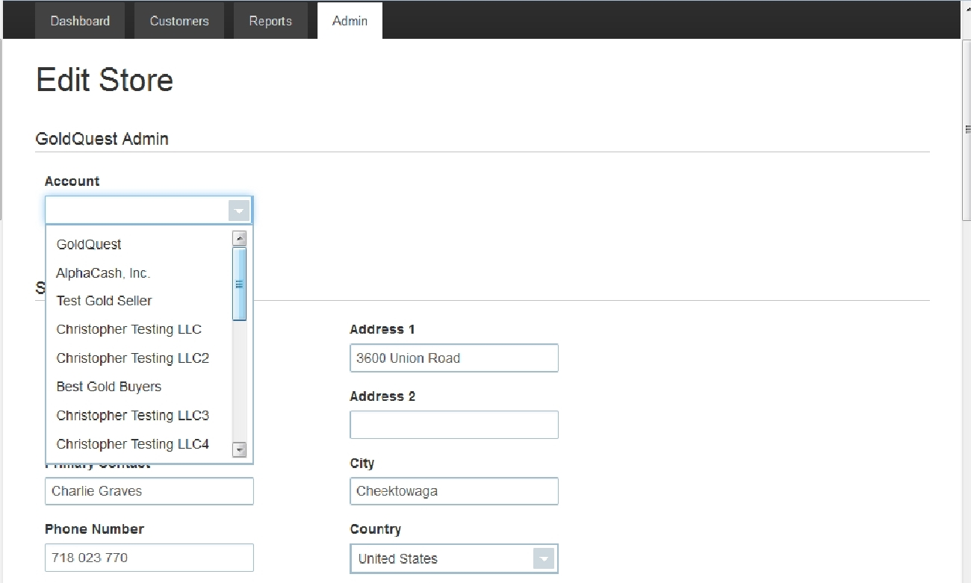

Image 2.2.E.4.b: Editing a Store

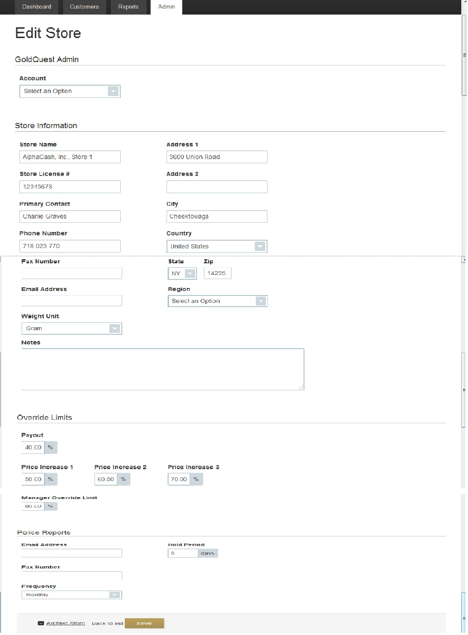

Image 2.2.E.4.c: Editing a Store

Subsection 2.2.E.5: Creating or Editing Regions
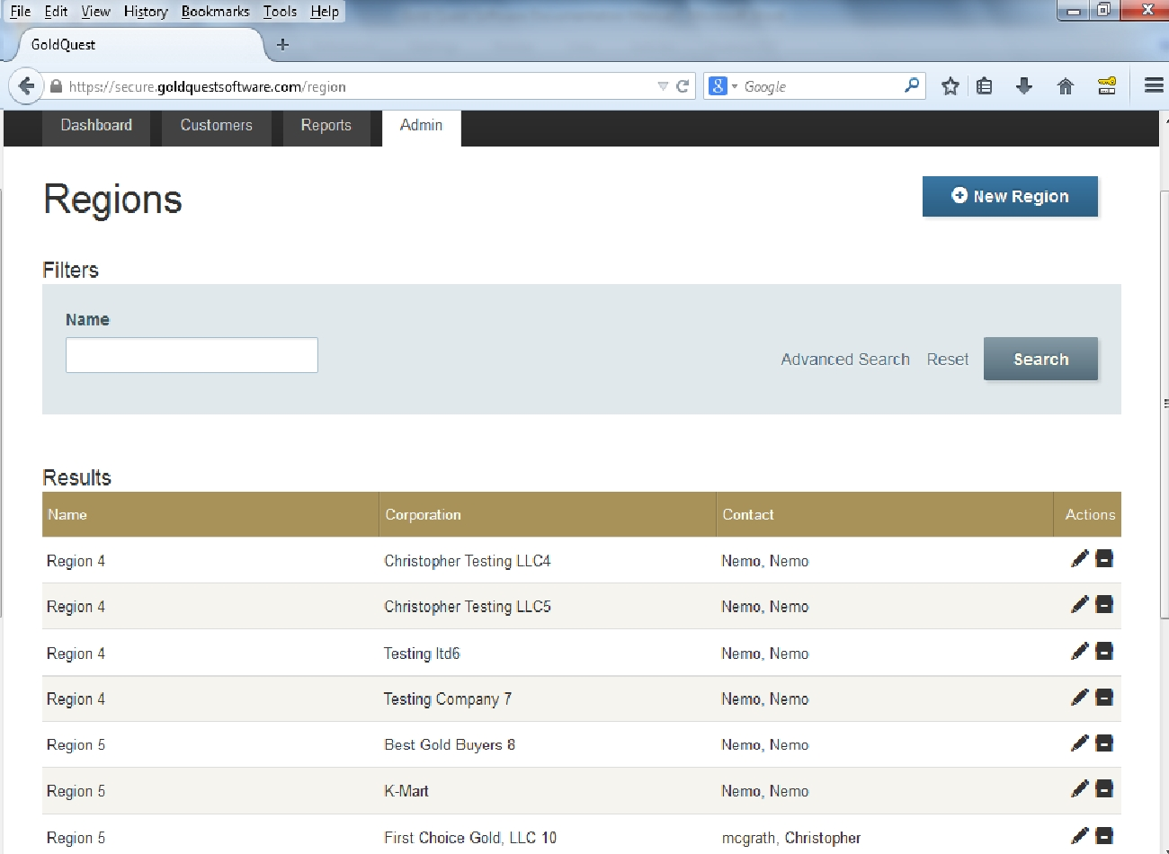

Image 2.2.E.5: Inside the Regions Category
A screen to create a new region or to edit is the same screen as shown in Image 2.2.E.5.b: Editing a Region. Image 2.2.E.5: Inside the Regions Category above is an example of clicking into the Regions category from the Admin tab. To create a new region, click on the New Region button appears on right upper corner of the screen.
To edit Regions:
- Click Admin tab.
- Click Regions category.
- Click an icon appears as a pencil in image 2.2.E.4 to edit a region.
A screen similar to Image 2.2.E.5.b: Editing a Region will appear.
Corporation – This drop-down list appears only for Super Admin level log in. Companies will appear in this list if at least one company exists in the entire software environment.
Name – Enter the region name desire.
Contact – Choose the appropriate contact in the drop-down list.

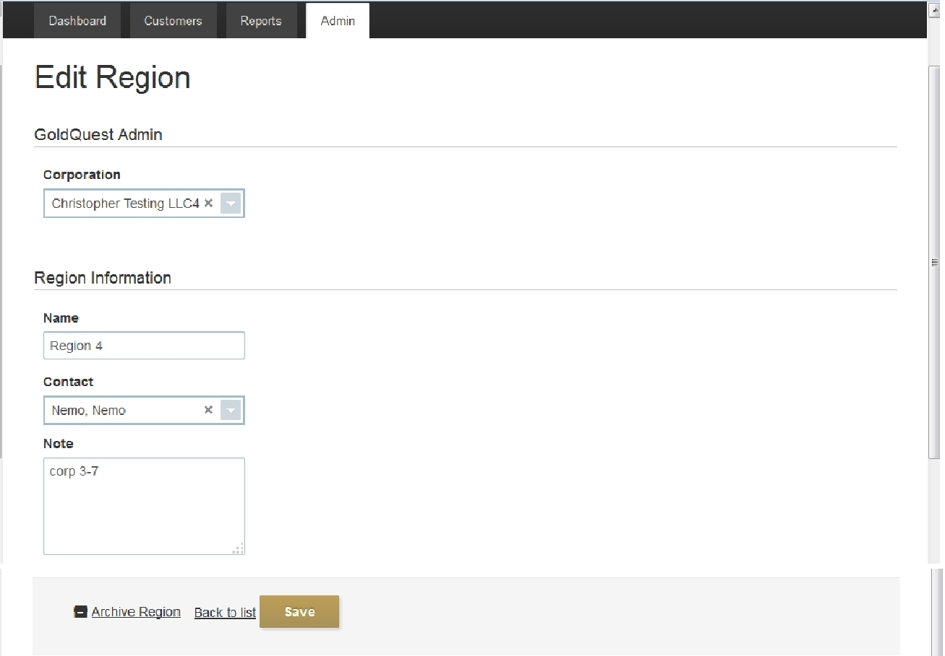

Image 2.2.E.5.b: Editing a Region

Subsection 2.2.E.6: Creating or Editing Referral Sources
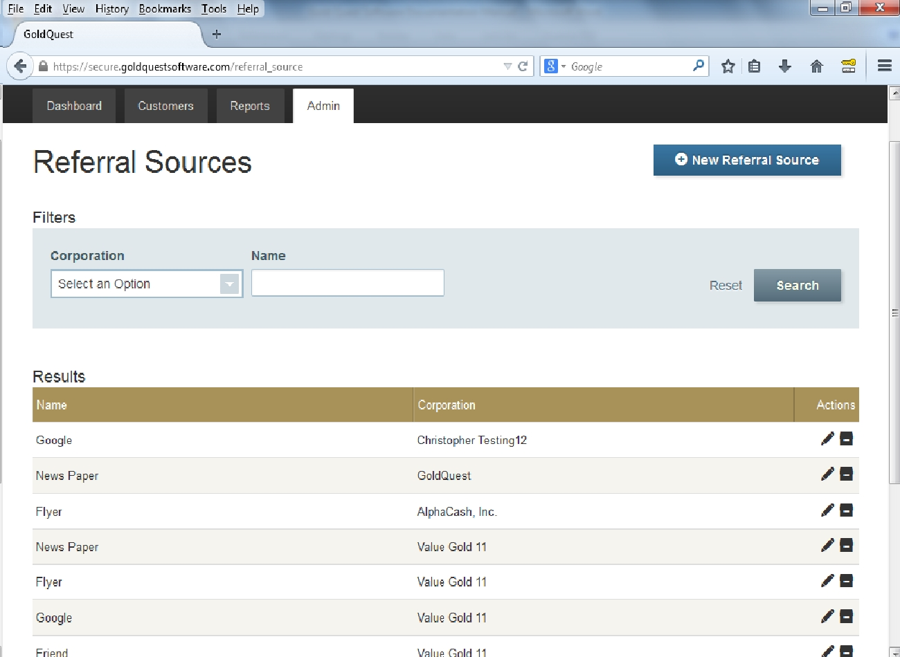

Image 2.2.E.6: Inside the Referral Sources Category
A screen to create a new Referral or to edit is the same screen as shown below in Image 2.2.E.6.b: Editing a Referral Source. Image 2.2.E.6: Inside the Referral Sources Category above is an example of clicking into the Referral category from the Admin tab. To create a new Referral Source, click on the New Referral Source button appears on right upper corner of the screen.

To edit Referral Sources:
- Click Admin tab.
- Click Referral Sources category.
- Click an icon appears as a pencil in image 2.2.E.6 to edit a Referral Source.
A screen similar to Image 2.2.E.6.b: Editing a Referral Source will appear.
Name – Enter the any text to describe the referral source, such as News Paper, Flyer, Google, and etc.
Corporation – Select from this drop down list to assign a corporation to the particular referral source entered above. NOTE: This file will only appear for the Super Admin user.

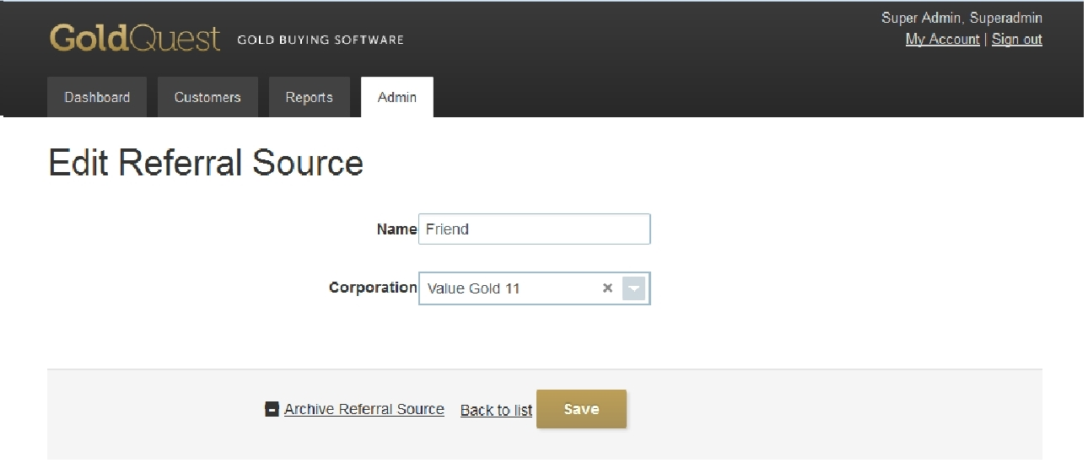
Image 2.2.E.6.b: Editing a Referral Source

Section 2.3: Transactions Icons at Reports for Super Admin
Reports tab for the Super Admin have sub categories. In the Transaction Category, there are three icons:
1. Transactions by Store
2. Transactions by Employee
3. Incomplete Transactions by Employee.

Subsection 2.3.A: Transactions by Store
Click on the icon appears as a house under Transactions category to see the list of all completed transactions. Under the ID column, clicking on the transaction IDs will display details of the completed buying transactions. All IDs generated in the software environment is unique. Transaction could be searched and filtered by buttons and drop-drown lists on top.
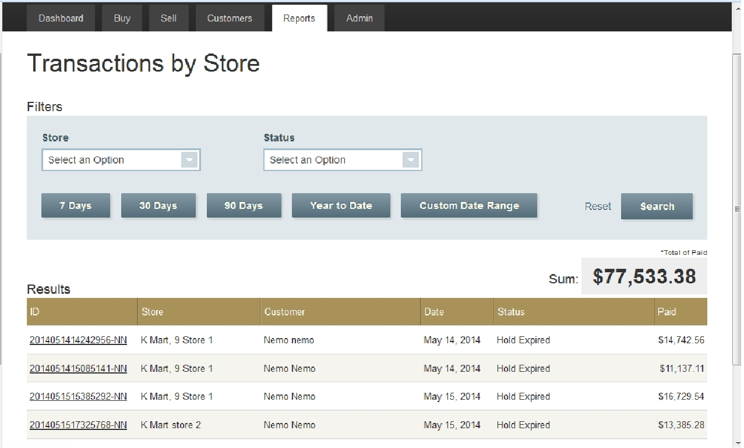
Image 2.3.A: Inside the Transactions by Store

Subsection 2.3.B: Transactions by Employee
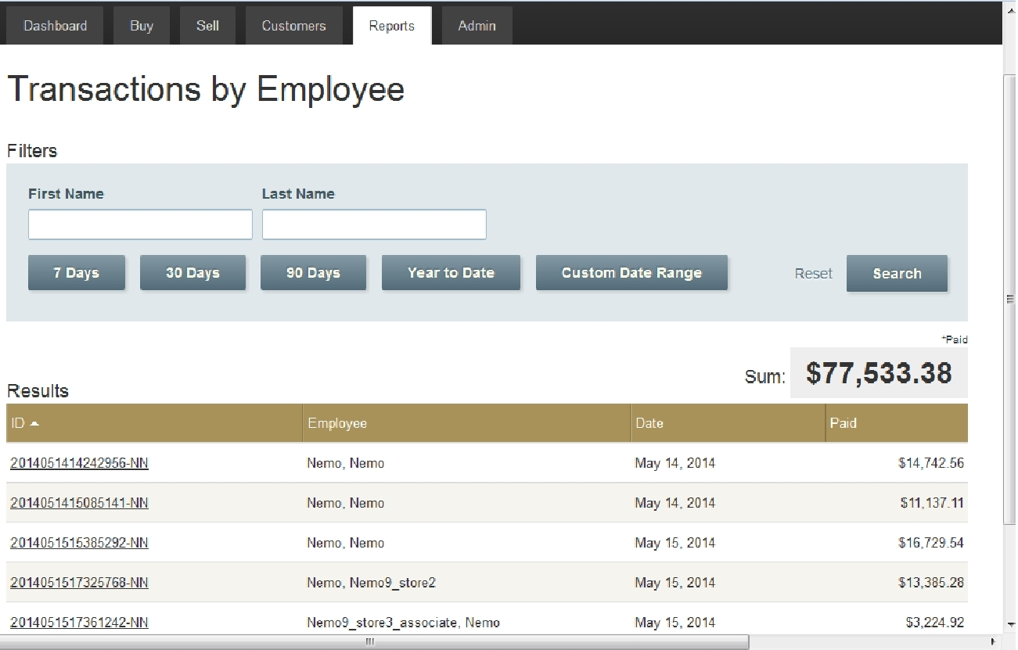

Image 2.3.B: Inside the Transactions by Employee
Click on the icon appears as two persons under Transactions category to see the list of all completed transactions by employees. Under the ID column, clicking on the transaction IDs will display details of the completed buying transactions. All IDs generated in the software environment is unique. Particular transactions by a specific employee could be searched and filtered by buttons and drop-drown lists on top.

Subsection 2.3.C: Incomplete Transactions by Employee
Click on the icon appears as a flag under Transactions category to see the list of all incomplete transactions by employees. If a transaction was interrupted for any reason, that transaction will be searchable in this category. Under the ID column, clicking on the transaction IDs will display details of the completed buying transactions. Any information that is not recorded will be left out as blank when a transaction ID is click to view the report. All IDs generated in the software environment is unique. Particular transactions by a specific employee could be searched and filtered by buttons and drop-drown lists on top.
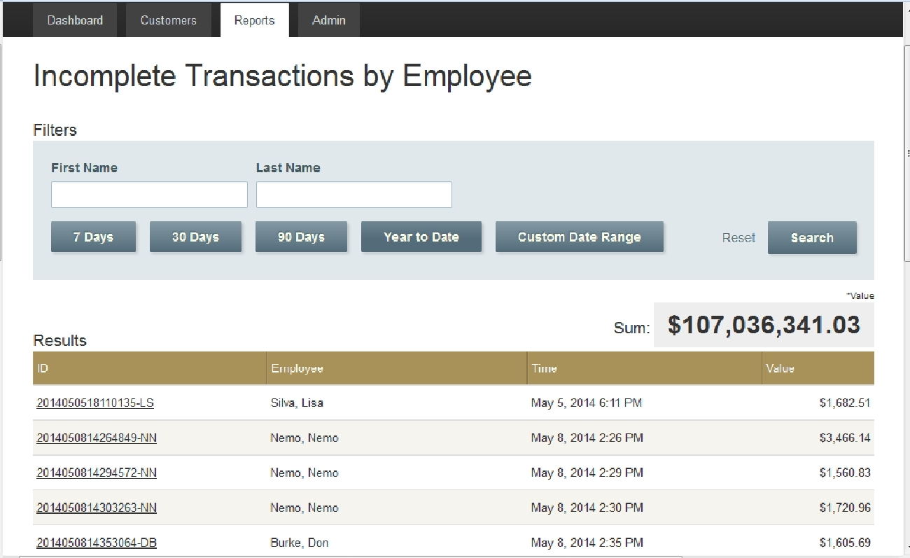

Image 2.3.C: Inside the Incomplete Transactions by Employee

Section 2.4: Shipments by Store Icon at Reports for Super Admin
In the Sales/ Shipments sub category for Reports tab, there is a Shipment by Store icon that appears as a house. Although Super Admin cannot make any transaction such as buying and shipping, Super Admin can view all transactions by all employees under all stores in the GoldQuest software environment.
Details of the transactions can be viewed by clicking on the first column Statement ID. Filter tools on top could be used more efficient searching.

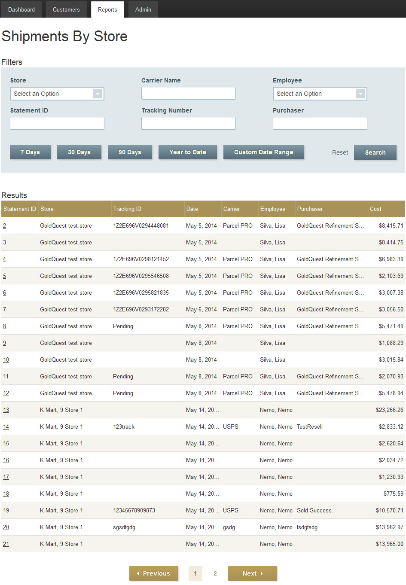

Image 2.4: Inside the Shipments by Store

Section 2.5: Inventory Icons at Reports for Super Admin
Reports tab for the Super Admin have sub categories. In the Inventory Category, there are two icons:
1. Inventory by Store
2. Inventory by Status.

Subsection 2.5.A: Inventory by Store
Click on the icon appears as a house under Inventory Category to see the list of Inventory. Inventory means a completed transaction that is available to ship out. Default list will display all the available inventory by all stores under all companies. Particular stores can be chosen in the drop-down list to filter out the available inventory by that store only. Inventories can also be filtered out or searched by time constraint buttons available on top. Under the Transaction ID column, clicking on the transaction IDs will display details of the inventory.
Status- shows whether an inventory is on hold or not. Inventories that show as “Hold Expired” under Status column are available for immediate shipping. Please see Hold Period under Subsection 2.2.E.4: Creating or Editing Stores for details.
Description-whatever was entered as description for the purchased item will show here. Description can be entered at buying.
Inscription- whatever was entered as inscription for the purchased item will show here. Inscription can be entered at buying.

Subsection 2.5.B: Inventory by Status
Click on the icon appears as an exclamation mark under Inventory Category to see the list of Inventory by Status. In this feature icon, the Super Admin and other users can easily filter out their inventories by status with the Status drop-down list on top.

Section 2.6: Transactions by Customer Icon at Reports for Super Admin
In the Customers Category, Transactions by Customer list is displayed when an icon appeared as a stack of IDs is clicked. In this feature icon, the Super Admin and other users can easily search or filter their customers by First, Last Name, or date ranges. Customer means a person who sells something to the store. Other users, such as employees, will not appear here for the Super Admin.
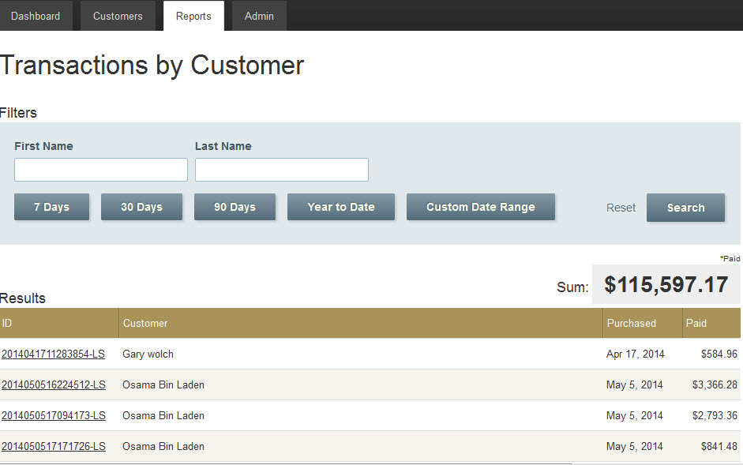

Image 2.6: Transactions by Customer

Section 2.7: Referrals by Store Icon at Reports for Super Admin

Under the Report Tab in the Referrals by Store Category, Referrals by Store list is displayed when an icon appeared as a house is clicked. In this feature icon, the Super Admin and other qualified users can easily search or filter to see how well their referral sources are doing.

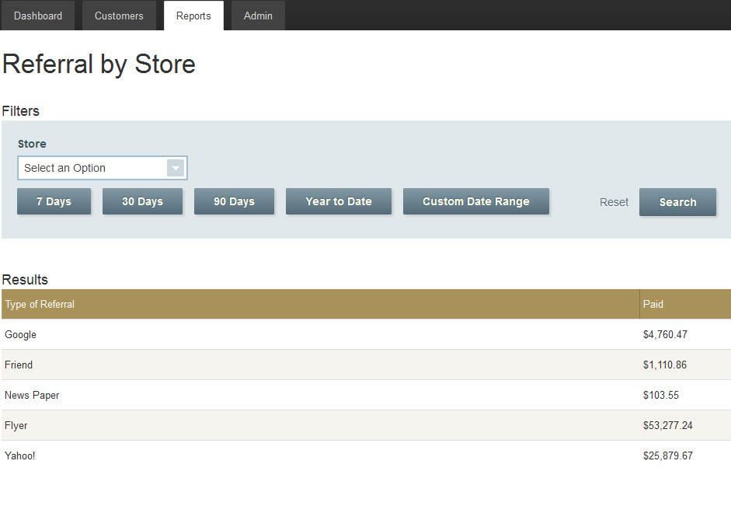

Image 2.7: Inside Referral by Store

There will be a Referral Source Drop-down box at buying, as shown in Image 4.1.2.b: Enter Customer Information. The payout amount in buying will be recorded and displayed here in Paid Column for corresponding referral sources.

Section 2.8: Points by Employee Icon at Reports for Super Admin

In the Points by Employee Category, Points by Employee list is displayed when an icon appeared as “two persons” is clicked. In this feature icon, the Super Admin and other qualified users can easily search or filter to see how well their employees are doing by accumulated amount of points or by dollar amount of transactions. A specific employee could be searched and filtered by First Name, Last Name, or time rang buttons on top.

Section 2.9: Financial Icons at Reports for Super Admin

Reports tab for the Super Admin have sub categories. In the Financial Category, there are two icons:

1. Receive Payments

2. Profit/Loss.

Subsection 2.9.A: Receive Payments

Click on the icon appears as a “star medal” in Financial Category under Report Tab to see the list of Receive Payments. Warning: Aside from helping troubled clients from GoldQuest administration, the Super Admin or Admin users do not really have practical purpose in using this function. Super Admin and Admin users entering random numbers in the Amount Received Boxes will create inconsistent reports for the stores under various corporations. The same warning applied to the Corporate users although the severity of the errors would be confined only to the stores under their corporation. This must be kept in mind with extreme cautions. The numbers entered here cannot be edited and undone in the automatically generated reports based on the figures entered.

Statement ID - click on this to see the details of the shipment.
Buyer – comes from Purchaser Name entered at selling or “GoldQuest Refinement …” will show if the shipment was made to GoldQuest. Please read on or jump to Image 4.2.2.a: Inside Create Shipping/ Sale Statements Category to see this.

Cost column shows the dollar amount particular stores paid to buy from the customers in stores plus costs for the shipping and the insurance.

Amount Received column is to be entered the amount received for the shipment when it was received, whether via electronic payment, by check, bank transfer, or etc, from the designated company, such as GoldQuest. When an amount is entered and Update Button is clicked, a page similar to Image 2.9.B: Profit/ Loss will appear. Disregard ling 3 and 4 in this image.

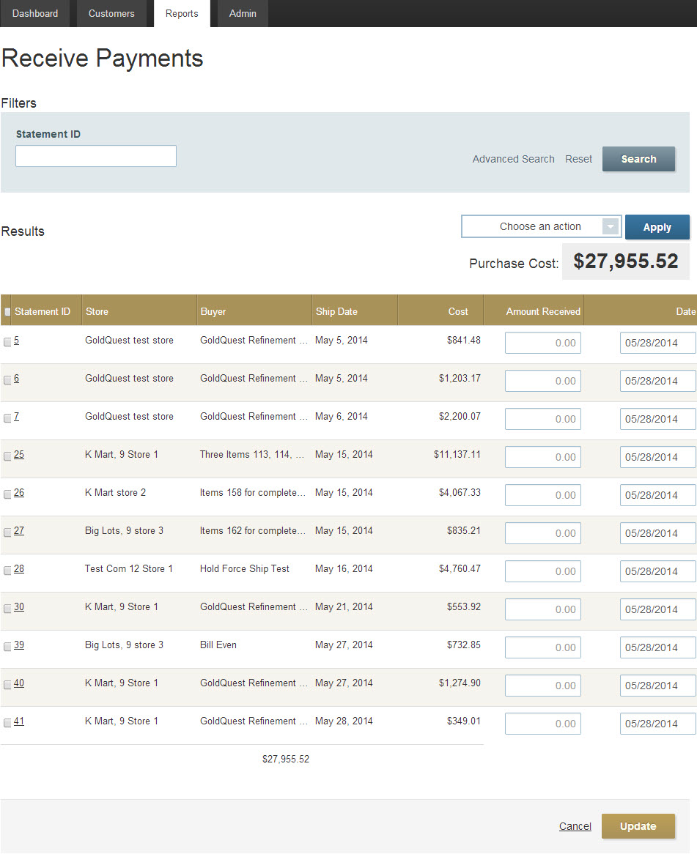

Image 2.9.A: Inside the Received Payments

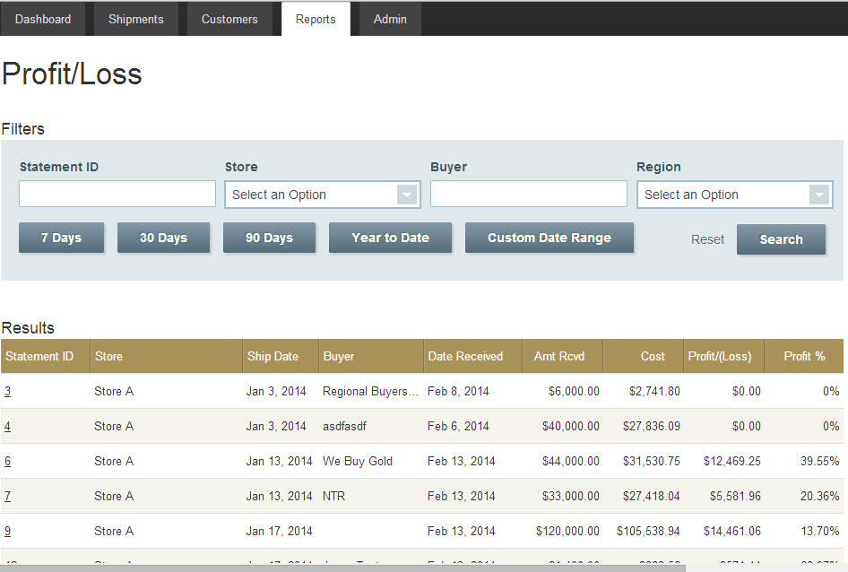

Image 2.9.B: Profit/ Loss

Subsection 2.9.B: Profit/Loss
Click on the icon appears as a “bar chart” in Financial Category under Report Tab to see the list of Profit/Loss. Display of this page can also be reached from clicking Update Button from Receive Payments as in Subsection 2.9.A: Receive Payments.
Profit (Loss) column is the result of Amt Rcvd subtracts Cost.
Profit % calculates (Profit (Loss)/ Cost) x 100. Although “Profit(Loss)” column will show the negative numbers in red fonts inside parentheses, such as ($2,739.80), “Profit%” will not show negative but only 0% for all negative percents.

Section 2.91: Customers Tab for Super Admin
In Super Admin account, click on Customers tab to see a page similar to Image 2.91. Click on an icon appears as a magnifying glass to see the details of an employee. Click on an icon appears as a pencil to edit. Clicking on an icon appears as a box will archive (delete) the employee from the GoldQuest software environment.
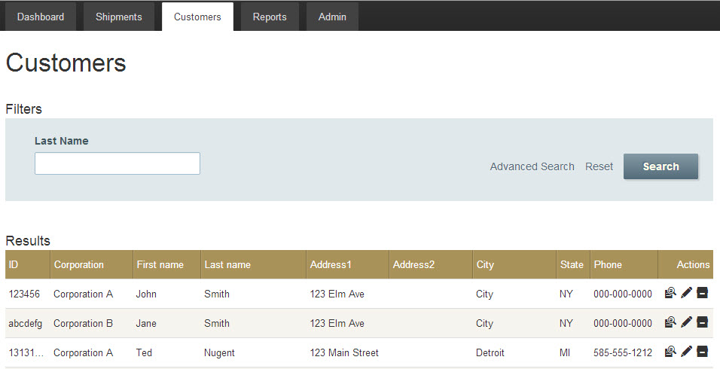

Image 2.91: Inside the Customers Tab

Section 2.92: Super Admin Limits

Subsection 2.92.A: Super Admin Cannot Make another Super Admin
At the time this manual is being written, Super Admin may be able create another Super Admin account, but new Super Admin is not functional and usable.

Subsection 2.92.B: Super Admin Cannot Trade
Although Super Admin can see all transactions by other users, (s)he cannot buy or ship anything.

Chapter 3

Admin

Only Super Admin or existing Admin can create a new Admin user.
Admin user has the all authority and functionalities the Super Admin has except the Stores Category function under the Admin Tab is not available for this user.
To create a new Admin account, please see Subsection 2.2.E.1: Creating a New Employee.
To see the detail functionalities of an Admin user, please read the entire Chapter 2 Super Admin, but skip Subsection 2.2.E.4: Creating or Editing Stores for this does not apply for the Admin users.

Chapter 4

Corporate

A Super Admin, Admin, or existing Corporate account can create a new corporate user. To create a new Corporate account, please see Subsection 2.2.E.1: Creating a New Employee.
Corporate users has the all authority and functionalities the Super Admin has except they cannot create new corporations. Super Admin and Admins’ accounts are not visible to Corporate users. Only the stores, employees, inventories, activities and records under each corporation are visible in their accounts. One Corporate account is not visible to another corporate account if the corporations are different. Corporate Accounts are the only accounts with the Admin Tab in a corporation. All other accounts in a corporation, such as regional manager, manager, and associate do not have Admin Tab to be able to do administrative functionalities. All other external accounts, such as Police, and Auditor also do not have Admin Tab. In addition to Super Admin and Admin’s functionalities, Corporate have two additional Buy and Sell tabs.

Section 4.1: Buy Tab for Corporate

To buy from a customer, click on Buy tab. There are four steps in buying.

Subsection 4.1.1: Step 1: Enter Item Information

An image similar to Image 4.1: Inside the Buy Tab will appear. If a corporate user isn’t assigned to any particular store, an image similar to Image 4.1.b: Inside the Buy Tab for ‘Global’ Corporate User will appear. ‘Global Corporate User’ means that user can buy for any store from their account and transaction records will go into selected store records. A list of stores under that particular corporation will appear to choose from. Three types of metals: gold, silver, platinum, can be purchased using GoldQuest software.

Live Price is the current NYS spot price (market price) for a particular period of time for that metal. This price gets updated every 10 minutes in GoldQuest software.

Purity levels are available in the drop down boxes. Enter the known information, such as results of testing, in purity level.

Weight- enter the number from the weighing scale. The unit of the weight will appear as gram or penny weight, depending on the preferences set up at store creation.

Description can be selected from available options from a drop-down list or can be entered manually by typing.

Inscription is an optional field that can be entered by typing.

Payout price is calculated based on the payout % entered at creating a store. Please see Image 2.2.E.4.c: Editing a Store. The default price for this will increase if price increase 1, price increase 2, price increase 3, or manager override features are used. Here is an example calculation of a piece of that weighs 62.2 gram (2 troy oz) and have 17k purity level. NY spot price for 1 troy oz. is 1,264.96 for this calculation.
1264.96 x 2 x (17/24) x .4 = 716.01
-First parameter 1264.96 is the spot price for 1 troy ounce.
-The 2 is for 2 troy ounces because 62.2 grams is approximately 2 troy ounces. The GoldQuest software uses 31.10347680 grams for one troy ounce.
-Third parameter (17/24) is because the purity is 17 karat out of 24 karat (pure gold).
-The last parameter .4 is for 40% which is set at store payout price.
Price Increase functionalities, such as tick One, tick Two, tick Three, and Manager Override, only work for gold buying. Please see Subsection 2.2.E.4: Creating or Editing Stores for detail explanations for these functions. In Image 4.1.c: ‘Manager Override’ for Buy, a Corporate or Manager can enter desired amount at “Amount To Increase To” Box as long as it does not exceed the amount shown in the “Available Increase Up To” which is the percent payout limit calculation set in store preferences.
Total Payout will add all the payouts for all items, but price increase will not be applied to total payout on the items that are silver and platinum. Again, Price Increase do not function for silver and platinum at this development stage.
Enter the desired preferences for the fields above and click next button.
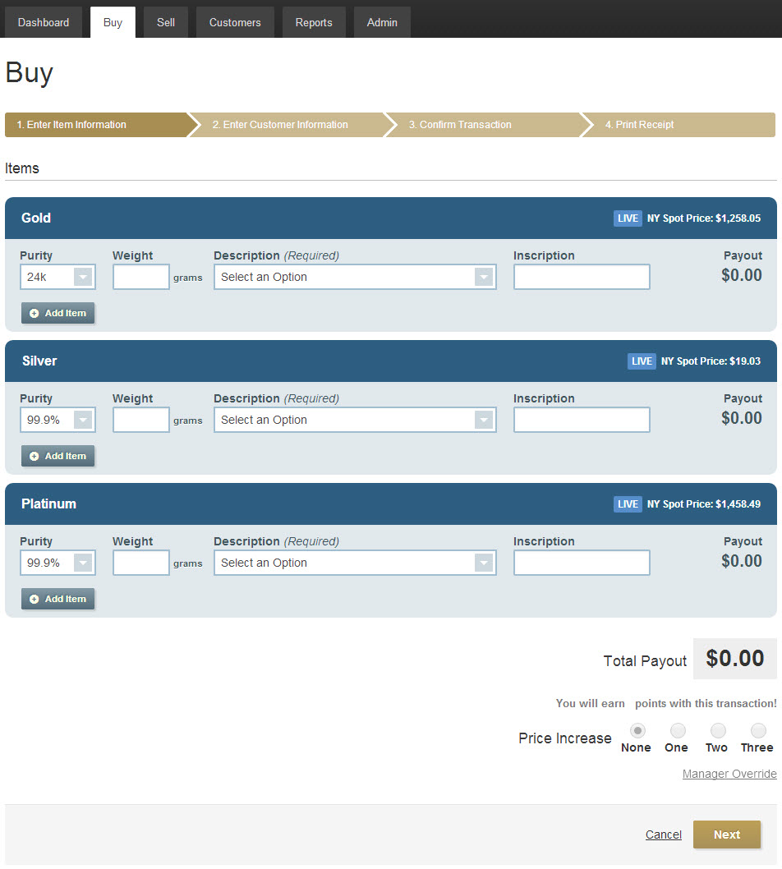

Image 4.1: Inside the Buy Tab
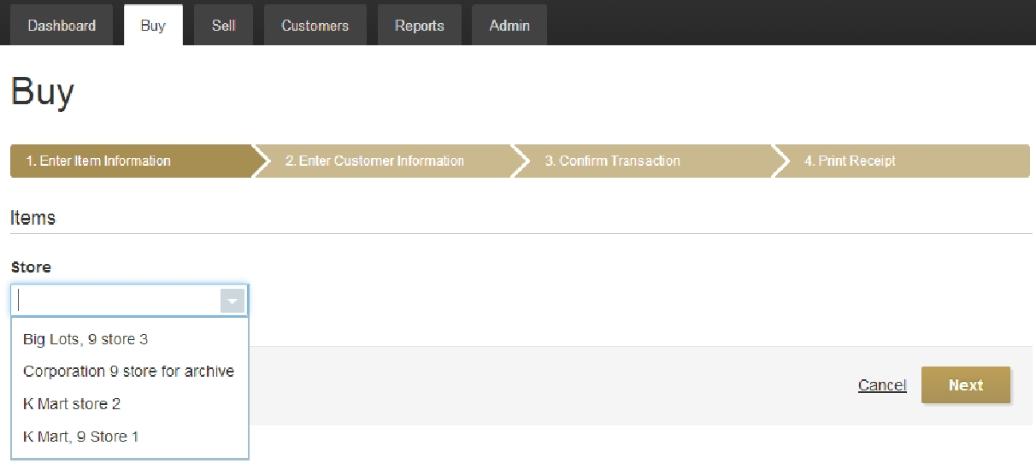

Image 4.1.b: Inside the Buy Tab for ‘Global’ Corporate User

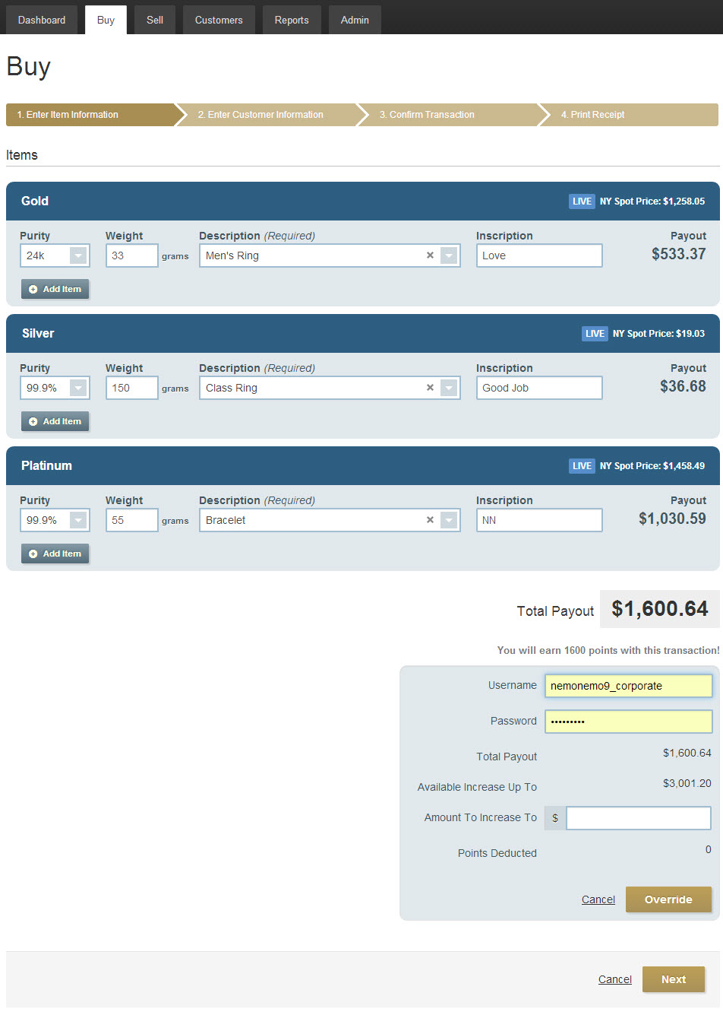

Image 4.1.c: ‘Manager Override’ for Buy

Subsection 4.1.2: Step 2: Enter Customer Information

Enter the appropriate information for the fields and click next button. NOTE: THE CUSTOMER INFORMATION ENTERED HERE MAKES AD-HOC QUERY TO GOVERNMENT DATABASE AND DOES INSTANT CRIMINAL BACKGROUND CHECK. IF THE CUSTOMER HAS CRIMINAL RECORDS, A WARNING POP UP BOX WILL APPEAR ON SCREEN, as shown in the Image 4.1.2: Government Warning Pop-up Box for Criminal Background Check.

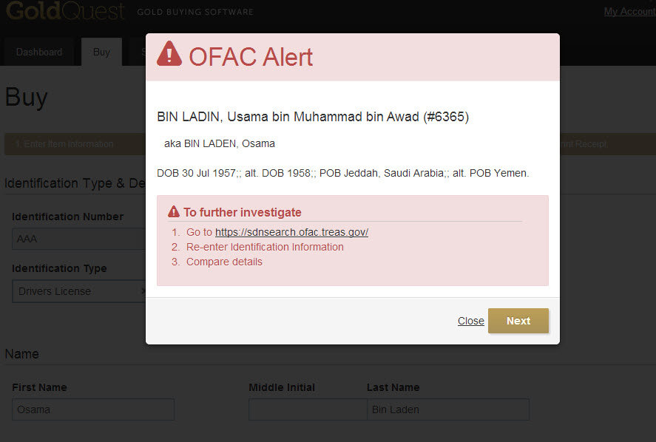

Image 4.1.2: Government Warning Pop-up Box for Criminal Background Check

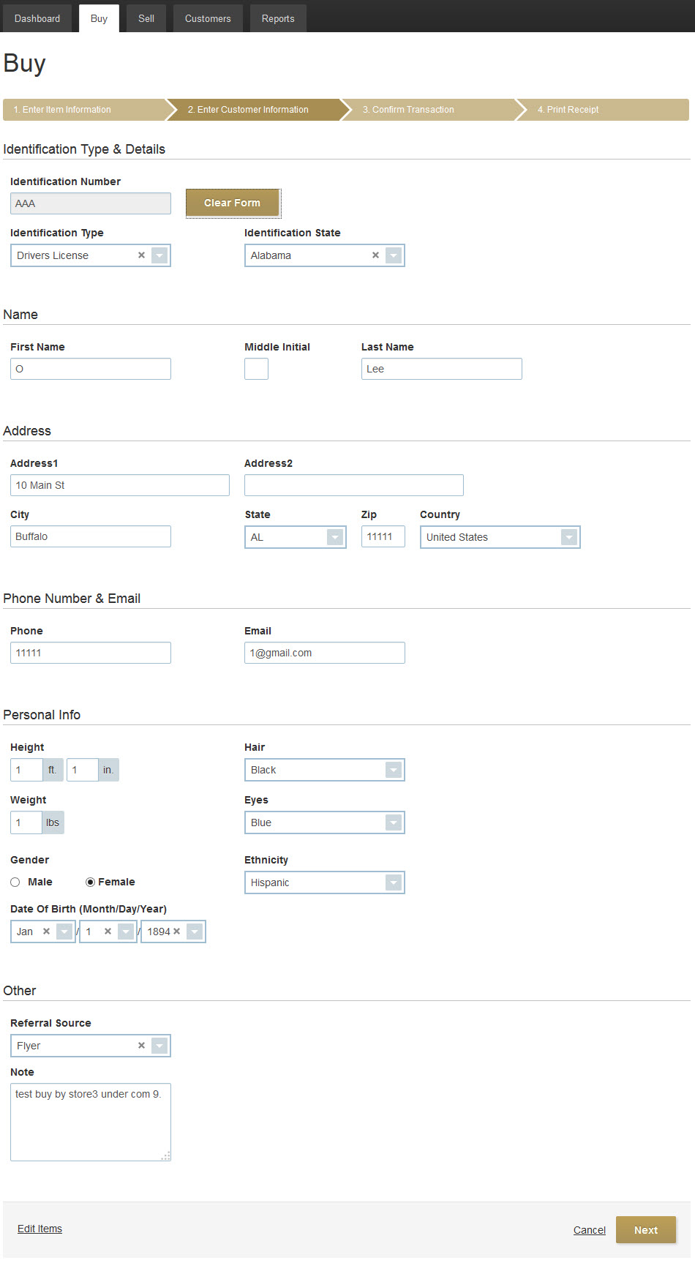

Image 4.1.2.b: Enter Customer Information

Subsection 4.1.3: Step 3: Confirm Transaction
A screen similar to Image 4.1.3 Confirm & Print Receipt will appear. Clicking on the Confirm & Print Receipt button will generate a new page on a new window. The click will log out the employee doing the transaction as well if “Employee Force Logout” check box was check at the Company preferences. In addition, transaction is considered completed at this point and it will appear in the inventory. Incomplete transactions are searchable under incomplete transactions by employee.
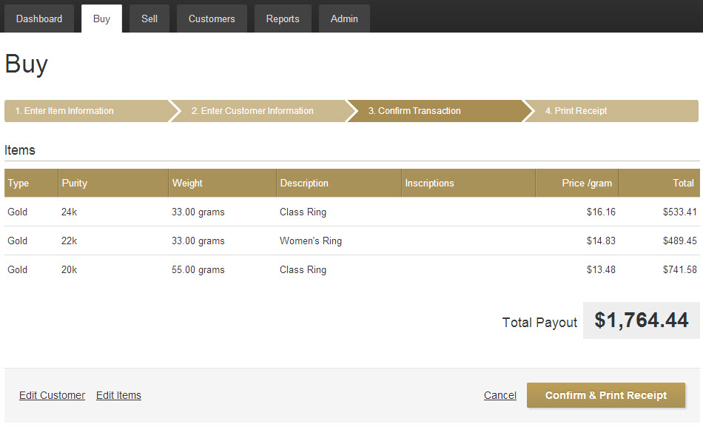

Image 4.1.3 Confirm & Print Receipt

Subsection 4.1.4: Step 4: Print Receipt
This is an optional step to save the generated receipt as a pdf file or to print.

Section 4.2: Sell Tab for Corporate

Accumulated inventories that are cleared of hold period are available to sell. Click Sell Tab to being the selling process. There are four steps in selling.

Subsection 4.2.1: Step 1: Choose Items to Sell

An image similar to Image 4.2: Inside the Buy Tab for ‘Global’ Corporate User will appear if it is a Global Corporate User. ‘Global Corporate User’ means that user can sell for any store from their account and transaction records will go into selected store records. A list of stores under that particular corporation will appear to choose from.

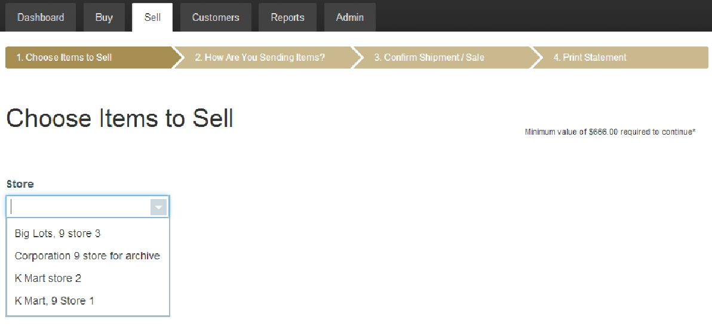

Image 4.2: Inside the Buy Tab for ‘Global’ Corporate User

An image similar to Image 4.2.b: Inside Choose Items to Sell will appear if it is not a Global Corporate User. Click on the transaction IDs to choose which items to sell or check the whole transaction box to sell everything within a particular transaction. Click Next Button on top.

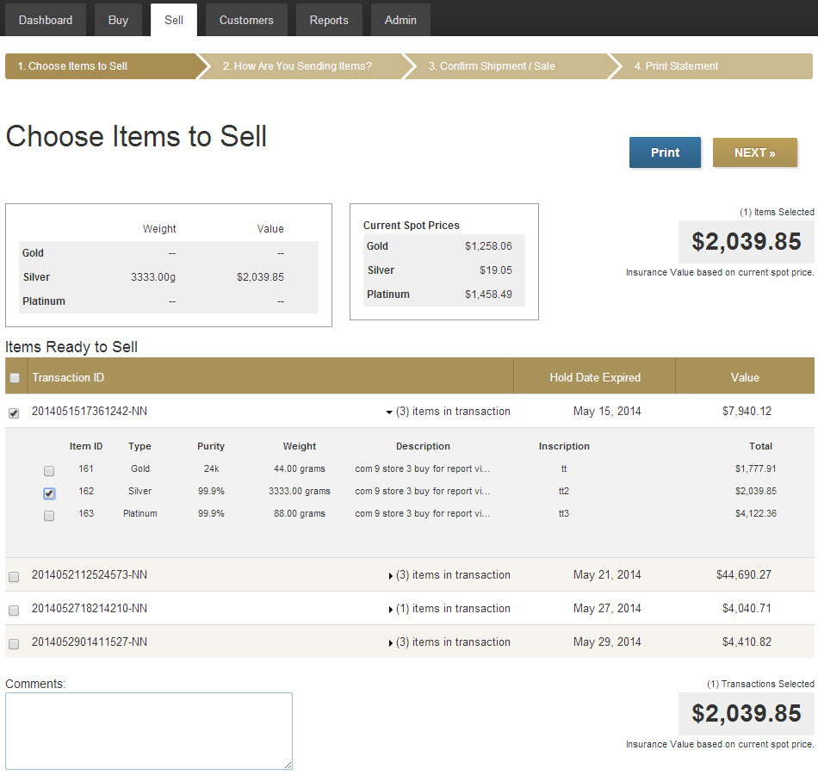

Image 4.2.b: Inside Choose Items to Sell

Subsection 4.2.2: Step 2: How Are You Selling Items?

At this step a user have two options to choose as shown in Image 4.2.2: How Are You Selling Items.

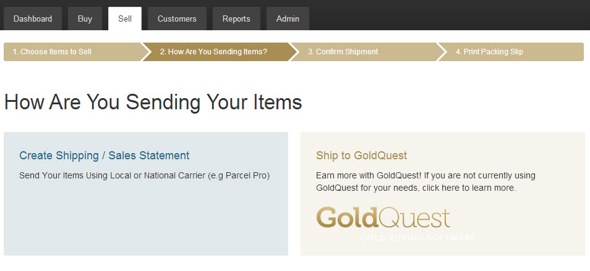

Image 4.2.2: How Are You Selling Items?

Create Shipping/ Sale Statements Category is for shipping to other sources the store wants to sell to. Click on this category if you desire and enter the appropriate information on the next screen. Click on the Next Button will go to next step Confirm Shipment/ Sales.

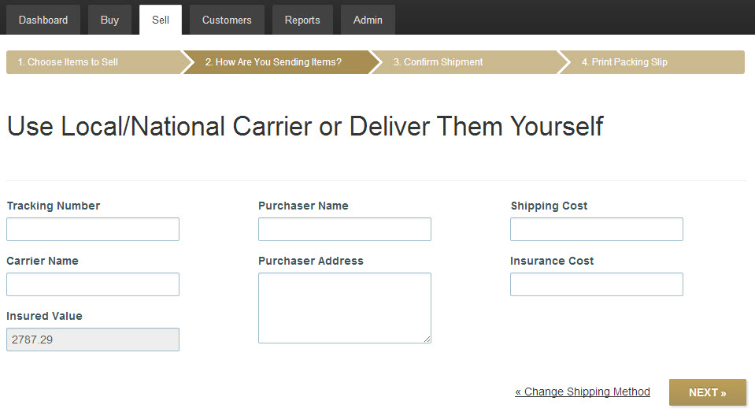

Image 4.2.2.a: Inside Create Shipping/ Sale Statements Category

Sell to GoldQuest Category is for shipping to GoldQuest Refinement Services LTD. Click on this category if you desire. Filling additional information isn’t required. Click on the Next Button will go to next step Confirm Shipment/ Sales. Selling to GoldQuest will present an automated online shipping label at Step 4. Click on the Print Mailing Label Button to print it. The shipping label can be open in a browser or photo windows photo viewer for immediate printing or saved as file as show in the Image 4.2.2.b: Obtaining the Shipment-Label to Ship to GoldQuest.

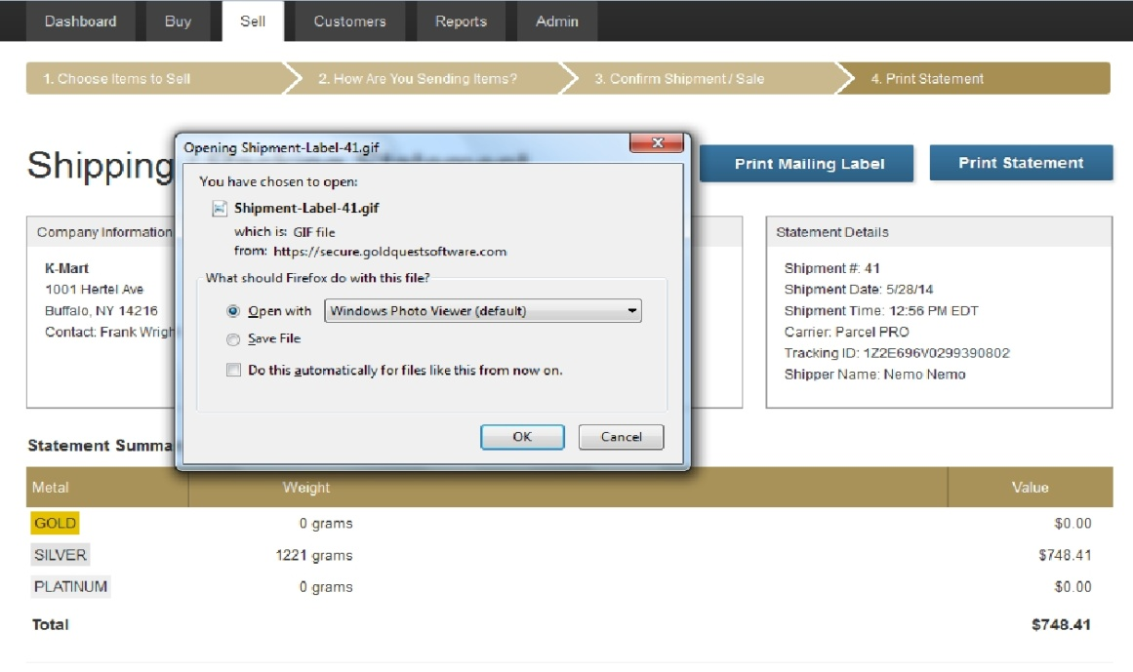

Image 4.2.2.b: Obtaining the Shipment-Label to Ship to GoldQuest

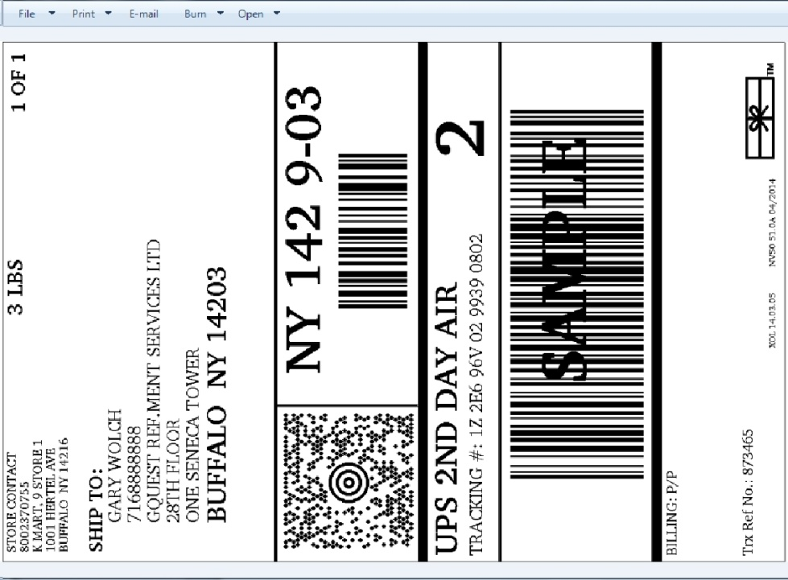

Image 4.2.2.c: Sample Shipment-Label to Ship to GoldQuest

Subsection 4.2.3: Step 3: Confirm Shipment/ Sales

Clicking on the Confirm Shipment/ Sales Button will clear the inventory from the database, created a new record in the database for shipments, and will go to the next step Print Statement.

Subsection 4.2.4: Step 4: Print Statement

Clicking on the Print Statement Button will generate a page on a new window with transaction details. This page can be saved in pdf format or printed.
Chapter 5

Manager-Region

A Super Admin, Admin, or Corporate user can create a new Manager-Region account. To create a new Manager-Region account, please see Subsection 2.2.E.1: Creating a New Employee.
Manager-Region (regional manager) account does have an Admin Tab; regional manager’s Report Tab is different from the Corporate and has reduced functionalities.
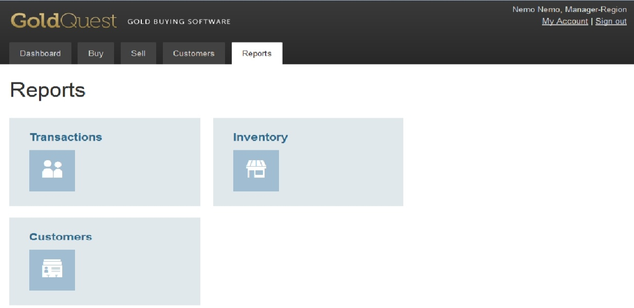
Transactions Category for the regional manager has only Transaction by Employee icon. Please see Subsection 2.3.B: Transactions by Employee for the functionalities of this icon.
Inventory Category for the regional manager has only Inventory by Store icon. Please see Subsection 2.5.A: Inventory by Store for the functionalities of this icon.
Customers Category for the regional manager has only Transactions by Customer icon. Please see Section 2.6: Transactions by Customer Icon at Reports for Super Admin for the functionalities of this icon.
Buy Tab for the regional manager is similar to the Corporate account. Regional Manager can buy for many stores as long as the stores are properly assigned under a particular manager’s regions. The Corporate user must set this up. This is how a Corporate user must do for a regional manager to be able to buy for multiple stores:
- Create a Region and name it, i.e. Region 5. How to create or edit region, please see Subsection 2.2.E.5: Creating or Editing Regions.
- Assign the particular regional manger you want to that region in the Contact Box and save.
- In Admin Tab, edit stores and assign that Region 5 in the Region Box. How to create or edit stores, please see Subsection 2.2.E.4: Creating or Editing Stores. Edit and assign more store if you want multiple stores under one regional manager.
- In Admin Tab, edit that particular regional manager employee and make sure (s)he isn’t assign to any store in the Store Box. How to create or edit employees, please see Subsection 2.2.E.2: Editing Employees.
For more information on the Buy Tab of the regional manager, please see Section 4.1: Buy Tab for Corporate.
Sell Tab for the regional manager is similar to the Corporate account. Regional Manager can sell for many stores as long as the stores are properly assigned under a particular manager’s regions. The Corporate user must set up in Admin Tab to have this function. Please see the Buy Tab above to accomplish this. Please see Section 4.2: Sell Tab for Corporate for more information on functionalities of Sell Tab tab.

Chapter 6

Manager-Store

A Super Admin, Admin, or Corporate user can create a new Manager-Store account. To create a new Manager-Store account, please see Subsection 2.2.E.1: Creating a New Employee.

Manager-Store (store manager) account does not have an Admin Tab; store manager’s Report Tab is different from the Corporate, and regional manager and has reduced functionalities.

Transactions Category for the store manager has only Transaction by Employee icon. Please see Subsection 2.3.B: Transactions by Employee for the functionalities of this icon.

Customers Category for the store manager has only Transactions by Customer icon. Please see Section 2.6: Transactions by Customer Icon at Reports for Super Admin for the functionalities of this icon.

Buy Tab for the store manager is the same as the Corporate account, except that Global User functionality is not available. Please see Section 4.1: Buy Tab for Corporate for the functionalities of this tab.
Sell Tab for the store manager is the same as the Corporate account, except that Global User functionality is not available. Please see Section 4.2: Sell Tab for Corporate for the functionalities of this tab.
Customers Tab for the store manager is the same as the Super Admin account. Please see Section 2.91: Customers Tab for Super Admin for the functionalities of this tab.

Chapter 7

ASSOCIATE

A Super Admin, Admin, or Corporate user can create a new Associate account. To create a new Associate account, please see Subsection 2.2.E.1: Creating a New Employee.

Associate account does not have an Admin Tab.

Reports Tab for the associate’s Report Tab only has Customers Icon. Please see Section 2.6: Transactions by Customer Icon at Reports for Super Admin for the functionalities of this icon.

Buy Tab for the associate is the same as the Corporate account, except that Global User functionality is not available. Please see Section 4.1: Buy Tab for Corporate for the functionalities of this tab.

Sell Tab for the associate is the same as the Corporate account, except that Global User functionality is not available. Please see Section 4.2: Sell Tab for Corporate for the functionalities of this tab.

Customers Tab for the associate is the same as the Super Admin account. Please see Section 2.91: Customers Tab for Super Admin for the functionalities of this tab.

Chapter 8

AUDITOR

A Super Admin, Admin, or Corporate user can create a new Auditor account. To create a new Auditor account, please see Subsection 2.2.E.1: Creating a New Employee.

Auditor account does not have an Admin Tab, Buy Tab, Sell Tab, and Customers Tab.

Report Tab for the auditor is the same as all the functionalities of the Corporate account. For respective functionalities of the Report Tab for the auditor, please see:

Section 2.3: Transactions Icons at Reports for Super Admin
Section 2.4: Shipments by Store Icon at Reports for Super Admin
Section 2.5: Inventory Icons at Reports for Super Admin
Section 2.6: Transactions by Customer Icon at Reports for Super Admin
Section 2.7: Referrals by Store Icon at Reports for Super Admin
Section 2.8: Points by Employee Icon at Reports for Super Admin
Section 2.9: Financial Icons at Reports for Super Admin.

Chapter 9

POLICE

Although Super Admin, Admin, or Corporate user can create a new Police account, the functionalities of this account is not yet developed at the time this user guide is being written.

