Instruction at 0x00007FFBF2D1D1AD Referenced Memory at

0x0000000000000068

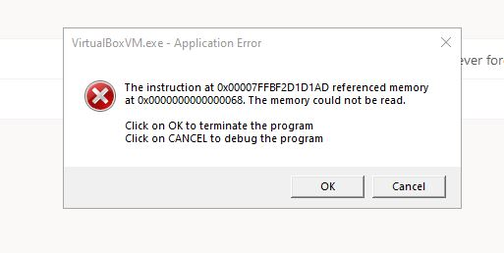

Dreadful error message “the instruction at 0x00007FFBF2D1D1AD referenced memory at
0x0000000000000068. The memory could not be read.

This happened after GuestAddition Update to VBoxGuestAdditions_6.1.10.iso at VMBox, Virtual Box, or VBox (whatever you call it). All seem to work well until the Guest OS reboots and it will crash every single time.

The fix:

1. Boot into the Guest OS, but press SHIFT during boot.
2. Get into menu shown, 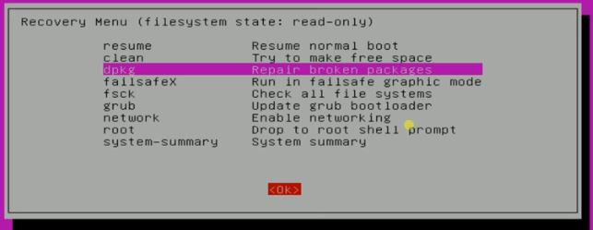
3. Select dpkg Repair broken packages.

