MySQL/MariaDB Error #1050

This error typically happened at data transfer, data migration, or data import from the backup .sql file. This will happened both in phpmyadmin web interface or command line, it doesn’t matter. The error looks like
MySQL said:
#1050 - Table ‘TABLE_NAME' already exists.
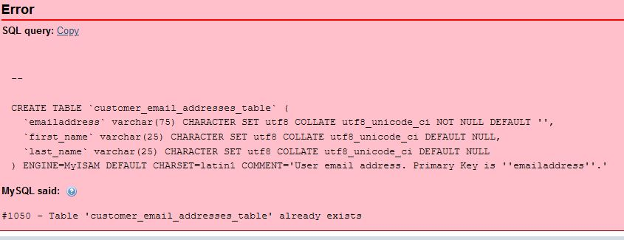

Many people are picking their brains all over the internet forums, but no one seems to be able to figure out the exact cause of the problem or real solution to it. The closest best solution someone figured out was that creating different database name and import backup .sql file to it will solve the problem. However, we can’t change the database name in a lot of scenarios; we want the same exact database name for the backup file to restore at.

This occasion usually happened at forceful system delete of the database files. Although all database files, and directories of the loss data were gone from hard drive somehow by intentional/unintentional delete, or some system disaster, the system memory, which MariaDB or MySQL allocated exclusively for its usage, remembers it and thinks those lost data tables or databases are still there. When importing the backup, it complains saying certain tables or databases are there. The whole system must be rebooted in order for the MariaDB or MySQL to forget those memory allocations.

Software Engineer Christopher McGrath
www.aaw.link

